Autumn 1 2018 - Year 1L
I would just like to start by saying what a wonderful start to the new school year! All the children have settled in very well to their new year group and all have worked extremely hard in every aspect of their school life and have done so right from the start. I am so proud of each and every one of them and what they have achieved in these past eight weeks. Well done!
We have been learning about many different things, so here is a brief description what we have been doing in class.
English
So far, we have read lots of really funny stories, such as ‘Class Two at the Zoo’, ‘Argh! Spider!’ and ‘Guess who?’ We retold the stories as a class, talked about the plot and characters and practised reading the stories in different accents. The children planned and then wrote their own adventure story, based on ‘Class Two at the Zoo’, a story about a school trip to the zoo that doesn’t quite go to plan, as a naughty and rather hungry snake follows the children around and eats them! Luckily, one plucky girl saves the day and all the children are saved! It was lovely to see how the children used their imaginations to plan a new adventure for the unlucky kids! We focused on adding interesting vocabulary to add detail and interest, and to make sure we included capital letters, finger spaces and full stops. We certainly have some budding authors in the making. We also read and performed poems about the weather, adding our own sound effects to our performances.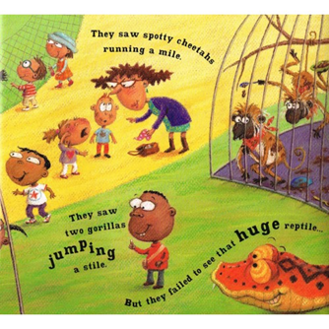

Maths
This half terms focus has been place value and counting. We have practised ordering numbers, finding missing numbers and learning to read, write and recognise numbers as numerals and written words. We have counted forwards and backwards, practised finding numbers that are more and less than a given number, and learned new vocabulary, such as greater than and less than, including new mathematical symbols. We have studied ordinal numbers – 1st, 2nd, 3rd, and have begun to investigate and add numbers using a method called the part whole method. Here is an example:
4
3
7

Science
In Science, we have started to look at and investigate materials. We have discussed what things are made of and why that material would be the best for that object, and have also learned new vocabulary that describes the properties e.g. solid, flexible and smooth. Next half term, we will continue to study materials and their properties and carry out investigations linked to our topic on Space. We will investigate which material would be most suitable to make a new waterproof space suit and a new helmet for Alan the Astronaut.

Geography 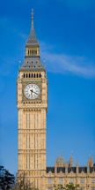
We have been looking at the four countries that make up the United Kingdom, naming them and their capital cities. We have identified them on maps, labelled our own maps and have also learned about famous landmarks that you would see if you were to visit these places. We have also learned the differences between rural, coastal and urban areas and studied our own local area around school.
Design Technology
As our topic is Space, we have turned our hands to rocket design! We looked at pictures and videos of real space rockets and learned the correct vocabulary for the different parts of the space crafts. We used our research to then design our own rockets, and noted what objects we would need to best make the different parts. We linked this to our Science work on materials, as we had to choose and give reasons for our choices. For example, ‘I chose to use a party hat to make the nose cone because it is the same shape.’ After half term, we will make our rockets and evaluate our finished models.
French
We have loved learning a new language and can now count to 10 in French. We can even read the French words for all the numbers too! We have learned the names for 10 different colours and have even written how to say hello and goodbye in French!
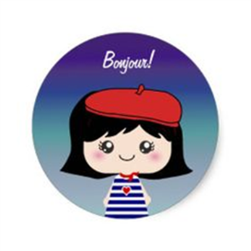

RE
In RE, we have learned about the Church and why it is a special place for Christians. We have learned the names for the different parts of a church and written our own prayers. After half term, we will visit St Paul’s church and talk to Father Richard about this special place and why it is important to Christians. We have also talked about the festival of Harvest.
PSHCE
As part of our lessons, we have talked about the British Value of respect and how we can show people respect. We discussed how respect works both ways and that if you show someone respect, they will show you it back. We continue to think about the importance of friendship and looking after each other. As the teacher, I am so lucky to have a class full of kind, thoughtful and respectful young people that think of others before themselves. We are definitely one happy class family!

Well, as you can see, we have had a very busy start to the new school year and all deserve a well-earned rest! Well done to all of you and I look forward to continuing our learning adventure after half term.
Mrs Larkin

