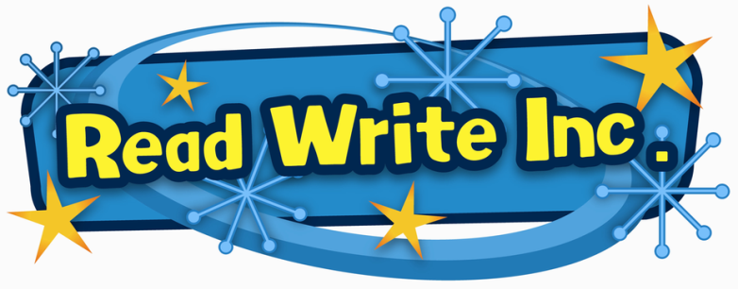
Read Write Inc

At Lynnfield Primary School we use Read Write Inc Phonics (RWI) to give your child the best possible start with their reading.

Read Write Inc. Phonics teaches children to read accurately and fluently with good comprehension. Children learn the English alphabetic code: first they learn one way to read the 40+ sounds and blend these sounds into words, then learn to read the same sounds with alternative graphemes.
They experience success from the very beginning. Lively phonic books are closely matched to their increasing knowledge of phonics and ‘tricky’ words and, as children re-read the stories, their fluency increases.
Along with a thought-provoking introduction, prompts for thinking out loud and discussion, children are helped to read with a storyteller’s voice.
The programme is designed for children aged 4-7. However, at LPS we begin the programme in Nursery and will continue teaching RWI to children beyond the age of 7 if they still need support in their reading

Fred Talk
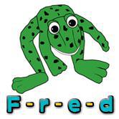
At school we use a puppet called Fred who can only speak in sounds, not whole words. We call this Fred Talk.
For example, Fred would say d-o-g, we would say dog. Your child is taught to hear sounds and blend them together in sequence to make a word. We start with blending oral sounds, then progress to reading the letters and blending them together to read the word.

Within all the books children will have red and green words to learn to help them to become speedy readers. Red words are words that are not easily decodable and challenge words to extend children’s vocabulary. Green words are linked to the sounds they have been learning and are easily decidable.
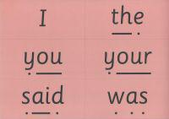
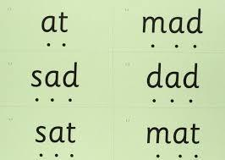

]

Nursery
When appropriate, children will be introduced to the initial sounds in short five minutes sessions.

Reception
In Reception all children will learn how to ‘read’ the sounds in words and how those sounds can be written down.

Year One & Year Two
Children follow the same format as Reception but will work on complex sounds and read books appropriate to their reading level. Daily sessions of RWI phonics last for one hour. Once children become fluent speedy readers and have reached the grey books they will then move off the program into an English group.

The children are taught the sounds in 3 sets.

Set 1 Sounds are taught in the following order together with rhymes to help children form the letters correctly and instantly recognise sounds ready for blending.

Set 1
Sound | Rhyme
m | Down Maisie then over the two mountains. Maisie, mountain, mountain.
a | Round the apple, down the leaf.
s | Slide around the snake
d | Round the dinosaur's back, up his neck and down to his feet.
t | Down the tower, across the tower,
i | Down the insects body, dot for the head.
n | Down Nobby and over the net.
p | Down the plait, up and over the pirates face.
g | Round the girls face, down her hair and give her a curl
o | All around the orange
c | Curl around the caterpillar
k | Down the kangaroos body, tail and leg
u | Down and under the umbrella, up to the top and down to the puddle
b | Down the laces, over the toe and touch the heel
f | Down the stem and draw the leaves
e | Slice into the egg, go over the top, then under the egg
l | Down the long leg
h | Down the horse's head to the hooves and over his back
sh | Slither down the snake, then down the horse's head to the hooves and over his back
r | Down the robot's back, then up and curl
j | Down his body, curl and dot
v | Down a wing, up a wing
y | Down a horn, up a horn and under the yak's head.
w | Down, up, down, up the worm.
th | Down the tower, across the tower, then down the horse’s head to the hooves and over his back
z | Zig-zag-zig, down the zip.
ch | Curl around the caterpillar, , then down the horse's head to thehooves and over his back
qu | Round the queen’s head, up to her crown, down her hair and curl
x | Cross down the arm and leg and cross the other way
ng | A thing on a string
nk | I think I stink
Please do not use letter names at this early stage.

Children will also use pictures for each sound to help recognise the sound and then form the shape of the sound.
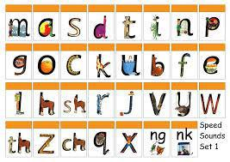
The children are then taught Set 2 Sounds - the long vowels. When they are very confident with all of set 1 and 2 they are taught Set 3 Sounds.
Long vowel sound | Set 2 Speed Sound cards  Teach these first | Set 3 Speed Sound cards
ay | ay: may I play | a-e: make a cake | ai: snail in the rain
ee | ee: what can you see | ea: cup of tea | e: he me we she be
igh | igh: fly high | i-e: nice smile
ow | ow: blow the snow | o-e: phone home | ao: goat in a boat
oo | oo: poo at the zoo | u-e: huge brute | ew: chew the stew
oo | oo: look at a book
ar | ar: start the car
or | or: shut the door | aw: yawn at dawn
air | air: that’s not fair | are: share and care
ir | ir: whirl and twirl | ur: nurse for a purse | er: a better letter
ou | ou: shout it out | ow: brown cow
oy | oy: toy for a boy | oi: spoil the boy
ire |  | ire: fire fire!
ear |  | ear: hear with your ear
ure |  | ure: sure it’s pure?
Order of Story books:

Books | Year Group Expectations
Red Ditty 1-10 | Reception
Green 1-10 | Reception
Purple 1-10 | Year one
Pink 1-10 | Year one
Orange 1-12 | Year one
Yellow 1-10 | Year one
Blue 1-10 | Year one/ two
Grey 1-13 | Year two

To help at home:

There are lots of practise tests online if you google ‘phonics screening check practise materials.’

You can make up your own alien words using set 1, 2 and 3 sounds. Please make sure children never write alien words, only read them.

Read favourite stories over and over again
Read some stories at a higher level than they can read themselves.
Listen to them reading their take home Phonics storybooks.

Useful links and websites

What is RWI? - https://ruthmiskin.com/en/find-out-more/parents/

How to say the sounds - https://www.youtube.com/watch?v=EYx1CyDMZSc
Teaching blending - https://www.youtube.com/watch?v=dEzfpod5w_Q

