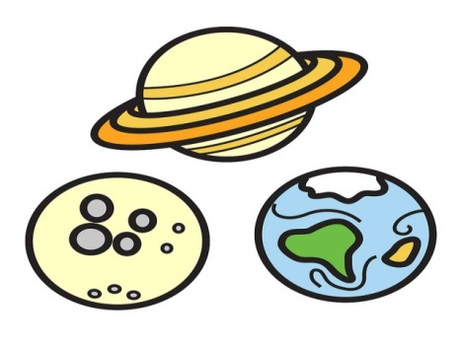

**Personal and social Development**

Learning how to be independent learners

Being a good friend

Learning about behaviour choices and consequences.

**Knowledge and Understanding of the world**

Recognises and talks about special events

Learns how to program a toy to move in a specific way

To look at similarities and differences between planets

**Physical development**

To travels with confidence and skill around, under, over, and through balancing and climbing equipment*.*

To use simple tools correctly eg scissors

To hold a pencil correctly to form letters

*To keep safe when moving around*

**Communication language and literacy**

Stories: Whatever next, aliens in underpants, Laura’s star, Rama and Sita, Nativity

Phonic activities

Songs and rhymes

Story telling using story cards, maps and stones

**SPACE**

**Maths**

Shape work

Counting forwards and backwards to10 and 20

Recognising numbers to 5, 10 and 20

Simple addition and Subtraction within 10.

Counting activities

Problem solving

**Autumn 2**

**Expressive arts and design**

Model making: rockets and planets

Colour mixing

Using instruments

Constructing for a purpose