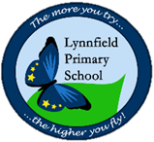
Reception – Home learning challenge 10

These challenges will also be uploaded to Tapestry where you can easily click on the links. https://tapestryjournal.com/

Start each day… | Practise mindfulness and take part in some morning yoga. Get the whole family to join in! | https://www.youtube.com/watch?v=U9Q6FKF12Qs
Understanding the World  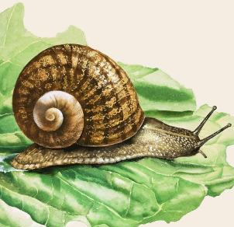 | 3.  https://www.youtube.com/watch?v=pLCtVGB1mFw
 | Watch the video above to learn about a minibeast you might find in your yard or garden. Use any books you have, research on the internet and ask others in your home. What can you find out about snails? Make a list of your findings. Can you write up to 3 sentences about snails? Ask an adult to take a photo of your hard work and upload it to Tapestry for us to see! You might even spot a snail and take a photo of you with it! We’ll be waiting!

Phonics | 1.  https://www.youtube.com/channel/UCo7fbLgY2oA_cFCIg9GdxtQ/featured
 | Please go to the Ruth Miskin YouTube channel, every weekday and watch the Speed Sounds Set 1 video from 09:30am ‘til 10:00am

Reading  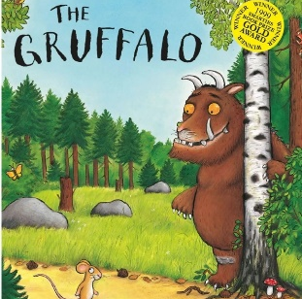 | 2.  https://www.bbc.co.uk/iplayer/episode/b00pk64x/the-gruffalo |  | Maths | 4.  https://www.topmarks.co.uk/subtraction/subtraction-to-10  https://www.topmarks.co.uk/learning-to-count/helicopter-rescue
 | Watch the story of The Gruffalos Child on BBC iPlayer or read the story with an adult if you have the book at home! Then, complete the different activities each day! |  |  | Play the games above and practise subtracting one number from another. Then, complete the activities below across the week.
Monday | Character description of the Gruffalo. What words are used throughout the story to describe him? |  | Monday | Line up 8 toys in a car park. If 3 toys drive away, how many will be left? Count back from 8 as you take away 3.
Tuesday | Gruffalo food menu. Throughout the story, the mouse talks about the Gruffalo’s ‘favourite foods’. Use these to make a menu for a Gruffalo themed cafe. |  | Tuesday | Set up some skittles or empty plastic bottles. How many skittles do you have? Roll a ball and count how many you have knocked down. How many do you have left?
Wednesday | Think about what you would do if you met the Gruffalo. What would you say? Would you trick the Gruffalo like the mouse did? Write about it using the title ‘If I met the Gruffalo...’ |  | Wednesday | Set up a small shop using toys or food. Give each item a price label with a price of up to 10p. Now, imagine that you are having a sale. Can each price go down by 2p?
Thursday | Create your own Gruffalo. Design your own fictional Gruffalo character with different features to the original. Draw/colour it and then label the main features. |  | Thursday | Find some building bricks or blocks in two different colours. Make a tower using one colour, while your partner makes a tower in the other colour. Are your towers the same? Which tower used fewer bricks? Which has more?
Friday | Identifying rhyming pairs in the story. Can you spot the rhyming words in the story? Write down or record any rhyming pairs you can find. |  | Friday | Place 10 small treats on a plate. If you eat 5, how many will you have left? How do you know? Can you eat 5 and check?

