Year 1 – Home learning challenge 10
- Reading (20 mins) – choose something different to read! If you go for a walk you could read some street signs! Or, how about reading a magazine/newspaper?
- Spelling (15 mins) – choose 2 different words a day and write them in a sentence. Try to be creative!
- Maths (15 mins) – complete a task from the fluency ladder – only move onto the next step when you are an expert! Ask people in your house to test you on a Friday (and maybe you could test them too!). Also, keep practicing your 2, 5 and 10 times tables.
- Mindfulness – find a calm, quiet space and listen to some relaxing music. Lay down and imagine you are in a relaxing place.
- Physical activity – create your own obstacle course. How many times can you complete it?
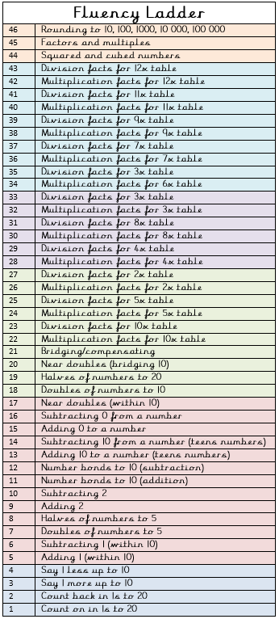
Spellings for the week
fur | letter
hurt | brother
church | farmer
purse | flower
purple | baker
Weekly fun task

BOGGLE!
Make as many words as you can using the letters in the grid below!
Make a list of all the words you can think of. Why not challenge a family member?!
a | s | t | e
p | d | e | f
n | m | c | i
o | u | b | l

