Year 2 – Home Learning Challenge 10

Daily activities
- Reading (20 mins) – read a book you enjoy.
- Spelling (15 mins) – practise then choose 2 of the words from the box below and write them in a sentence.
- Maths (15 mins) – a task from the fluency ladder – only move onto the next step when you are an expert! Ask people in your house to test you on a Friday (maybe you could test them too!). Also keep practicing your 2, 5, 10- and 3-times tables on TTRockstars.
- Mindfulness – Breathing Hands: Spread one hand out like a star. Use the index finger on your other hand to trace the outline of your star hand. Take a deep breath in as you move to the top of your thumb and breathe out as you move down between your thumb and first finger. Take another breath in as you move to the top of your first finger then breathe out as you move down between your first and second finger. Repeat until you have taken five slow, deep breaths.
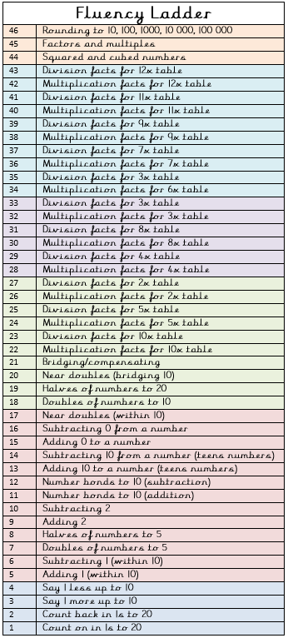
- Physical activities – How many different animals
can you move like?
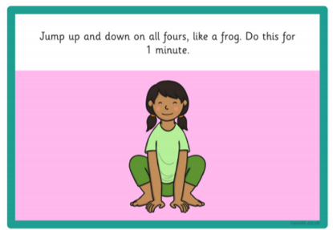

Spellings for the week - tion
station | fiction
section | nation
lotion | motion
potion | fraction
caption | father
option | rather
Weekly fun task
Have a bubble contest!

Who can make the highest number of bubbles in a minute? Who can create the biggest bubble?
Whose bubble will fly up the highest? Whose bubble stays for the longest time? Who can catch a bubble without bursting it?

Bubble mix
50ml washing-up liquid (one part)
300ml water (six parts)
1. Measure the washing-up liquid into a container, such as a jam jar or glass bottle.
2. Slowly add in the water, being careful not to create too many bubbles at this stage. Gently stir the mixture together to combine – a chopstick is perfect for this.
3. If you can, let the bubble mixture rest before using it, as it will make your bubbles even better.
4. When you’re ready, dip your bubble wand into the mixture and start blowing bubbles!

Homemade bubble wands
If you don’t have a wand from a store-bought pot of bubbles, don’t despair! You can have fun by looking for different items around the house that can be used to make bubbles. Here are some ideas to get you started:
Paperclips – bend them into wands or use as they are, straws, biscuit cutters, pipe cleaners, fly swatters

