Year 3 – Home learning challenge 10
Daily activities
- Reading Bug Club on activelearnprimary.co.uk and answer the quizzes or Oxford Owl RWI https://www.oxfordowl.co.uk/
- Spelling and Grammar (15 mins) practice using Look, Say, Cover, Write and Check – Test yourself on Friday. Try the activities allocated on activelearnprimary.co.uk
- Maths (15 mins) – a task from the fluency ladder – only move onto the next step when you are an expert! Test yourself on Friday.
- Mindfulness (10 mins) – find a calm, quiet space and listen to some relaxing music. Close your eyes, be very still and breathe in a calming colour for 3 counts and out for 4 counts.
- Physical activity – Listen to a piece of upbeat music every day, turn up the volume and dance like no-one is watching! Or try Joe Wick’s workout and Oti Mabuse’s dance class at 11:30am.
Spellings
superglue | superhero
supermarket | supersize
supersonic | supertanker
superman | superwoman
supercalifragilisticexpialidocious
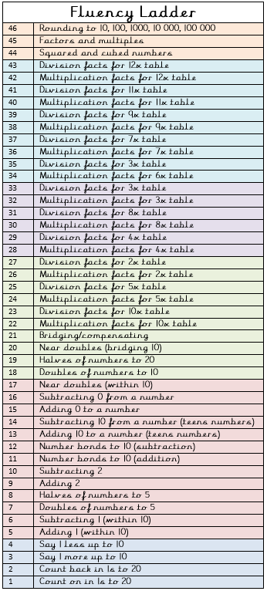
“Safety isn’t expensive – it’s priceless!”

Its Child Safety Week – Can you SPOT the DANGERS?
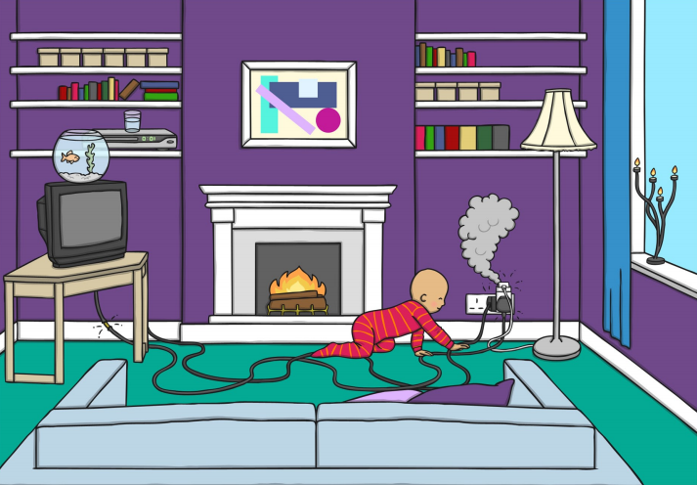
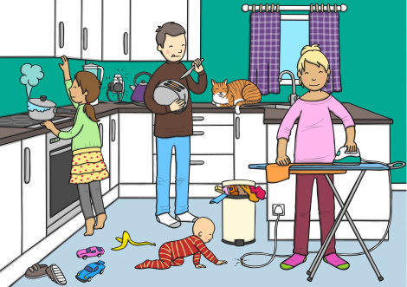
Download the parent pack - https://www.capt.org.uk/Handlers/Download.ashx?IDMF=063f132e-7d4d-46cd-b861-d97cc06fd9ad

