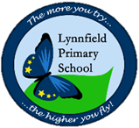
Year 5 – Home Learning Challenge 10

Daily activities
- Reading Log onto your active learn and discover the many books and grammar activities we have set for you. We are checking regularly to see if more work is required!
- Spelling (15 mins) Find the definition of any of the words you are unsure of. After that, write 9 sentences using these spelling rules.
- Mindfulness (10 mins) – Have a go at Cosmic yoga on Youtube.
Write a creepy setting description for this picture. Try to make it as interesting as possible by using figurative language!

Spellings
Nutritious | Nutrition
Cautious | Ambition
Scrumptious | Fiction
Ambitious
Fictitious

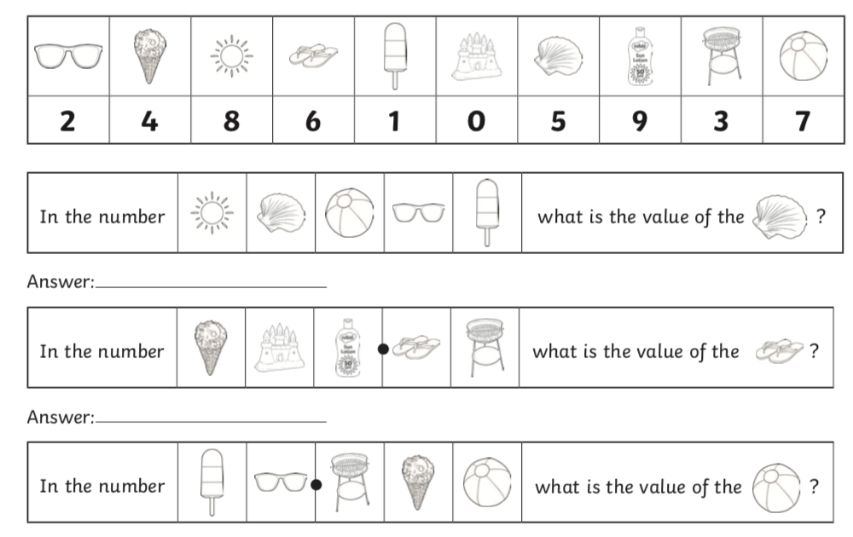
Weekly Fun Task
Crack these codes using the key provided
Have a go at making your own code and see if a family member can identify the value of your number.

