Year 1 – Home learning challenge 11
- Reading (20 mins) – read a book you enjoy with someone in your household
- Spelling (15 mins) – choose 2 different words a day and write them in a sentence. Try to be creative!
- Maths (15 mins) – complete a task from the fluency ladder – only move onto the next step when you are an expert! Ask people in your house to test you on a Friday (and maybe you could test them too!). Also, keep practicing your 2, 5 and 10 times tables.
- Mindfulness – find a calm, quiet space and listen to some relaxing music. Lay down and imagine you are in a relaxing place.
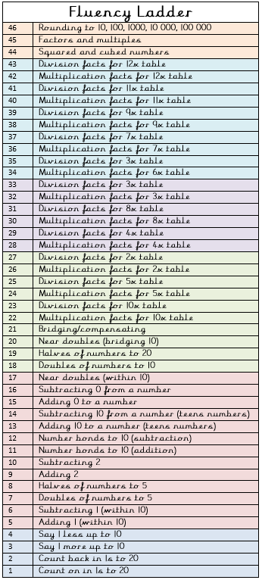
- Physical activity – try the 100 rep challenge! See if you can complete 20 of the following exercises: star jumps, squats, sit ups, press ups and frog jumps! Write down how long it takes you and try to beat your time the next day. HINT: If you are unsure of any of the exercises, look for a video on YouTube that will show you.
Spellings for the week
owl | paint
growl | faint
frown | snail
gown | rain
down | brain
Weekly fun task
Why not try this nature scavenger hunt if you go out to do some daily exercise with your family… See how many things you can find on the list! Maybe you could take a photograph of the interesting things you find, we would love to see them!
