Year 2 – Home Learning Challenge 11

Daily activities
- Reading (20 mins) – read a book you enjoy.
- Spelling (15 mins) – practise then choose 2 of the words from the box below and write them in a sentence.
- Maths (15 mins) – a task from the fluency ladder – only move onto the next step when you are an expert! Ask people in your house to test you on a Friday (maybe you could test them too!). Also keep practicing your 2, 5, 10- and 3-times tables on TTRockstars.
- Mindfulness – an extension of the Spidey Senses activity that can be used to help calm a busy mind and bring our awareness to the present moment. Think of 5 things you can see, 4 things you can touch, 3 things you can hear, 2 things you can smell and 1 thing you can taste.
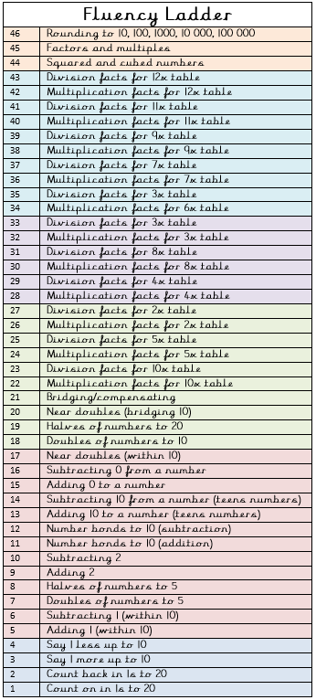
- Physical activity – Create small running
competitions for you and your family. Who is the
fastest runner? Who can run the furthest without
stopping?
Spellings for the week - es
bodies | babies
copies | cries
ladies | spies
tries | multiplies
carries | old
families | only

Weekly fun tasks
Try a weather-related task this week!

