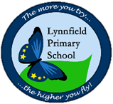
Year 3 – Home learning challenge 11
Daily activities

- Reading Bug Club on activelearnprimary.co.uk and answer the quizzes or Oxford Owl RWI https://www.oxfordowl.co.uk/
- Spelling and Grammar (15 mins) practice using Look, Say, Cover, Write and Check – Test yourself on Friday. Try the activities allocated on activelearnprimary.co.uk
- Maths (15 mins) – a task from the fluency ladder – only move onto the next step when you are an expert! Test yourself on Friday. Also try https://ttrockstars.com/
- Mindfulness (10 mins) – Try https://www.youtube.com/user/CosmicKidsYoga
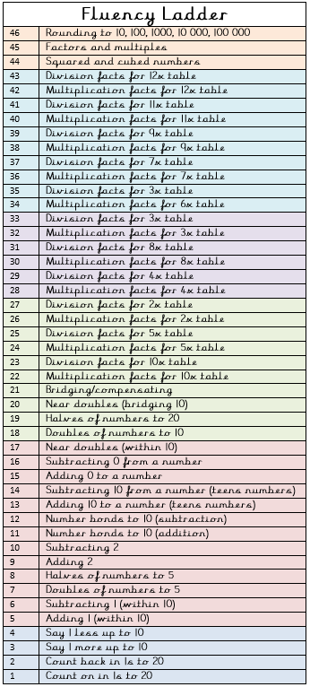
- Physical activity – Listen to a piece of upbeat music every day, turn up the volume and dance like no-one is watching! Or try Joe Wick’s workout and Oti Mabuse’s dance class at 11:30am.
Take a virtual tour of an art gallery
https://www.weareteachers.com/virtual-museum-tours/

Spellings
Subdivide | subheading
submarine | submerge
subsoil | subtitle
subway | subzero
subscribe  Weekly fun task – This week is Children’s Art Week.  Try out some of these fun art activities.  Don’t forget to send photos to our Facebook page | subconscious

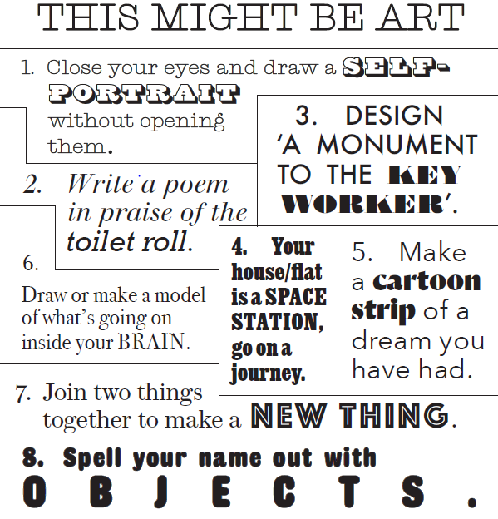
“Every child is an artist.”
Pablo Picasso

