Year 5 – Home Learning Challenge 11

Daily activities
- Reading for 20 mins per day- choose a book you love.
- Spelling (15 mins) practice using Look, Say, Cover, Write and Check – Test yourself on a Friday.
- Maths (20 mins) – a task from the fluency ladder – only move onto the next step when you are an expert! Test yourself on a Friday.
- Mindfulness (10 mins) – find a calm, quiet space and listen to some relaxing music. Close your eyes, be very still and breathe in for 3 counts and out for 4 counts.
- Physical activity – Listen to a piece of upbeat music every day, turn up the volume and dance like no-one is watching! Not into dancing? Why don’t you join the Body Coach for a live workout Monday – Friday at 9am? Go to YouTube and search ‘The Body Coach TV’.
Spellings
Special | Partial
Official | Essential
Financial | Initial
Social | Confidential
Artificial
Write a post card to a friend or a neighbour to tell them some of the things you have been up to during your time off.
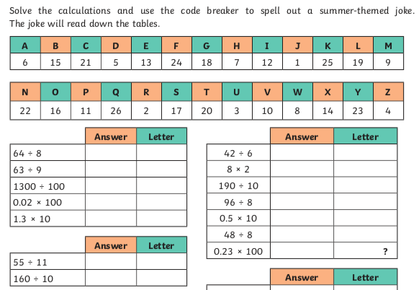
Write

Code Breaker

