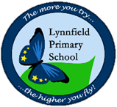
Year 6 – Home Learning Challenge 11

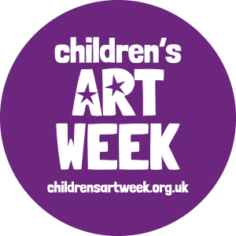
Over the past months, the COVID -19 pandemic has highlighted how essential creativity and the visual arts are for learning, connectivity and well-being.
Children’s Art Week.
In 2020, Children’s Art week will take place online and
within homes during June and July.
Each week will focus on a special theme.
Our 2020 themes are…
Week 1 – The Natural World.
Week 2 – Connecting across generations
Week 3 - Literacy and creative writing.

Spellings
Disastrous | Equipment
Embarrass | Especially
Environment | Exaggerate
Equip | Excellent
equipped | existence

- Reading – activelearn.co.uk. Access the wide range of books on here.
- Maths – Bitesize daily is offering many Maths lessons complete with video and resources.
- Physical activity – Remember there are ways to complete the daily mile. This is equivalent to 2,000 steps. How many times up and down the stairs would you need to do to complete this?
We would like you to use your imagination to create a piece of Art based on the Natural World.
BE CREATIVE!
Could you collect natural resources and create a picture using these?
Could you create a piece of Art using nothing but natural resources – berries and leaved were used in the Anglo Saxon period to create dye for clothing.
Create a sculpture by entwining branches and twigs.
Could you carv your artwork in to materials you have collected?

