Nursery – Home Learning Challenge 12
Start each day | Practise mindfulness and take part in some morning yoga. Get the whole family to join in | https://www.cosmickids.com/
Check Tapestry | Log on to your Tapestry account and check the memo page.  Don’t forget to add your own photos. | https://tapestryjournal.com/login/

Maths
Online activities
https://www.bbc.co.uk/cbeebies/shows/numberblocks
see if you can recognise your numbers.

Online activities
https://www.topmarks.co.uk/english-games
plenty of games to choose from. Have fun.
Reading
Every day share a book with a grown up. Ask your child
What can you tell me about this picture?
Who are the main characters?
Where is the story set?
What is going to happen next?
Maths
How many shapes can you find in your house?
Can you find some

Writing
Draw your family and write their names underneath.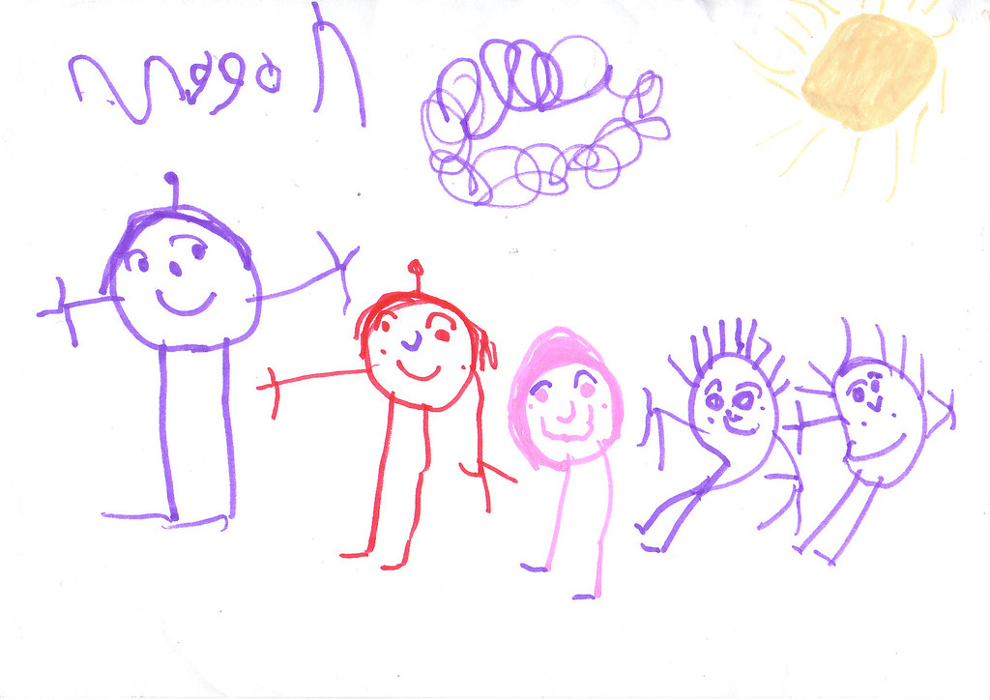
Can you write mam, dad, brother, sister?

