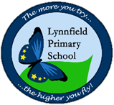
Year 1 – Home learning challenge 12
- Reading (20 mins) – read a book you enjoy with someone in your household
- Spelling (15 mins) – choose 2 different words a day and write them in a sentence. Try to be creative!
- Maths (15 mins) – complete a task from the fluency ladder – only move onto the next step when you are an expert! Ask people in your house to test you on a Friday (and maybe you could test them too!). Also, keep practicing your 2, 5 and 10 times tables.
- Mindfulness – find a calm, quiet space and listen to some relaxing music. Lay down and imagine you are in a relaxing place.
- Physical activity – try the 100 rep challenge! See if you can complete 20 of the following exercises: star jumps, squats, sit ups, press ups and frog jumps! Write down how long it takes you and try to beat your time the next day. HINT: If you are unsure of any of the exercises, look for a video on YouTube that will show you.
Spellings challenge!
This week, your spellings include the ‘ow’ sound (ow, brown cow) and the ‘ai’ sound (ai, snail in the rain). How many words can you come up with for each?

Scavenger Hunt!
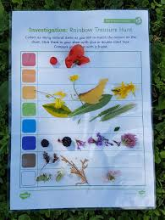
Find as many things of each colour of the rainbow and fill in the table attached below.
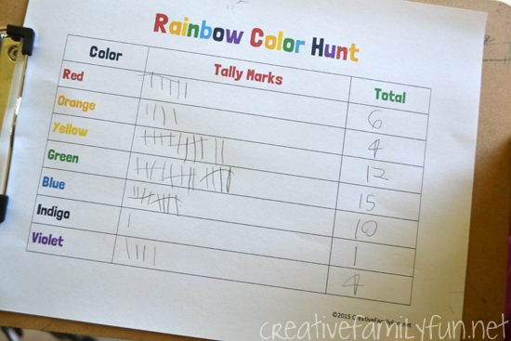
Then, count each object and fill in the tally chart (attached below) and find the total number of objects for each colour.
Consider the following questions:
- Which colour had the greatest total?
- Which had the least number of objects?
- Can you order the totals from greatest to smallest, and then smallest to greatest?
- Did any totals have equal amounts?

Rainbow scavenger hunt table
Red
Orange
Yellow
Green
Blue
Purple
Pink

Rainbow scavenger hunt tally chart
Colour | Tally marks | Total
Red
Orange
Yellow
Green
Blue
Purple
Pink

