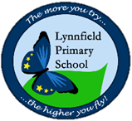
Year 2 – Home Learning Challenge 12

Daily activities
- Reading (20 mins) – read a book you enjoy.
- Spelling (15 mins) – practise then choose 2 of the words from the box below and write them in a sentence.
- Maths (15 mins) – a task from the fluency ladder – only move onto the next step when you are an expert! Ask people in your house to test you on a Friday (maybe you could test them too!). Also keep practicing your 2, 5, 10- and 3-times tables on TTRockstars.
- Mindfulness – Breathing Colours - Think of a relaxing colour. It can be any colour you like, as long as it is one that makes you think of relaxation. Imagine you are surrounded by the relaxing colour. No longer is the air clear, it is the relaxing colour. You can still make out shapes, but your world is now a different colour. Imagine that as you breathe in, you breathe in this colour too. See the colour filling up your lungs. Imagine as you breathe out, that your breath is the colour of stress. See the stress colour mix into the relaxing colour around you. Watch the stress colour slowly disappear. Breath in your relaxing colour. Breath out the stress colour.
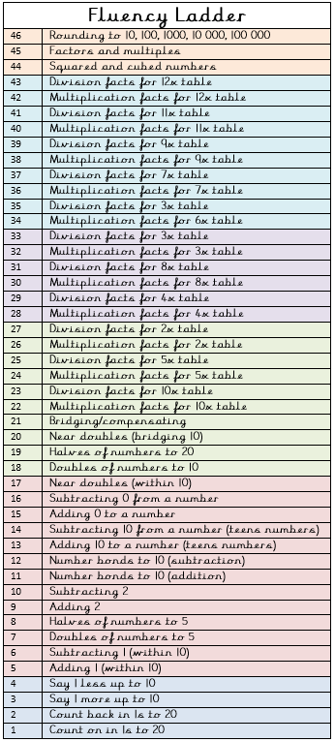
- Physical activity – Balance beam: This is an easy
one to set up and does not actually involve crafting
a real balance beam. Stick a long piece of tape to
the floor and get your children to walk across the
beam without falling off. You can make it more
challenging by having them hop from one balance
beam to another.
Spellings for the week - ness (1)
goodness | illness
sadness | madness
bitterness | fitness
foolishness | quietness
kindness | darkness
softness | coldness

Weekly fun tasks

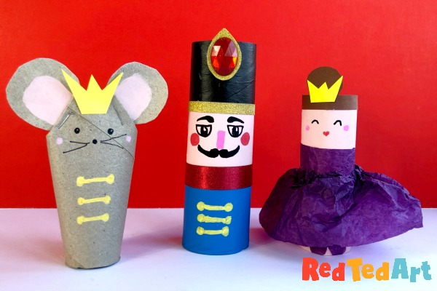

Try some Toilet or Kitchen Paper Roll Craft!

How many different characters can you make?

