Year 3 – Home learning challenge 12
Daily activities
- Reading Bug Club on activelearnprimary.co.uk and answer the quizzes or Oxford Owl RWI https://www.oxfordowl.co.uk/
- Spelling and Grammar (15 mins) practice using Look, Say, Cover, Write and Check – Test yourself on Friday. Try the activities allocated on activelearnprimary.co.uk
- Maths (15 mins) – a task from the fluency ladder – only move onto the next step when you are an expert! Test yourself on Friday. Also try https://ttrockstars.com/
- Mindfulness (10 mins) – Try https://www.youtube.com/user/CosmicKidsYoga
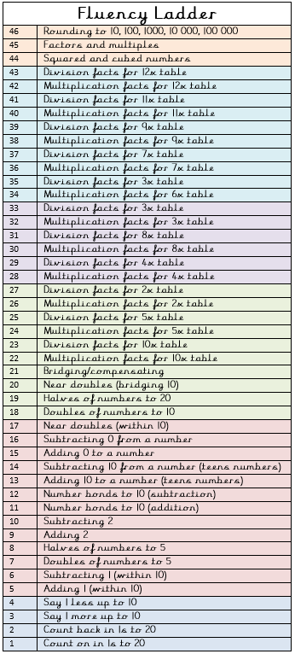
- Physical activity – Listen to a piece of upbeat music every day, turn up the volume and dance like no-one is watching! Or try Joe Wick’s workout and Oti Mabuse’s dance class .
Spellings
disagree | disappear
disapprove | dishonest
dislike | incapable
incomplete | incorrect
independent  Weekly fun task – Friday 19th June is  Wallace and Gromit’s Wrong Trousers Day!  Wear your silliest trousers or pyjama bottoms.  Watch these brilliant Wallace and Gromit’s Cracking Contraptions videos.  https://www.youtube.com/watch?v=gu2pxJo3cI0&list=PLSD4QfyS1DxXVYgPkEajIjBak1UkPSpjx  Have a go at designing your  own cracking contraption.  Don’t forget to send your  designs to our Facebook  page. | invisible

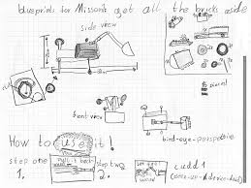
“All's well that ends well, that's what I say.”
Wallace

