Year 5 – Home Learning Challenge 12

Daily activities
- Reading for 20 mins per day- choose a book you love.
- Spelling (15 mins) practice using Look, Say, Cover, Write and Check – Test yourself on a Friday.
- Maths (20 mins) – a task from the fluency ladder – only move onto the next step when you are an expert! Test yourself on a Friday.
- Mindfulness (10 mins) – find a calm, quiet space and listen to some relaxing music. Close your eyes, be very still and breathe in for 3 counts and out for 4 counts.
- Physical activity – Listen to a piece of upbeat music every day, turn up the volume and dance like no-one is watching! Not into dancing? Why don’t you join the Body Coach for a live workout Monday – Friday at 9am? Go to YouTube and search ‘The Body Coach TV’.
Spellings
disagree | inhuman
inactive | misspell
mislead | unfair
mismatch | misunderstand
misbehave | mistreat
Can you create your own number jumble and challenge a family member? Try it out with different times tables.
Can you find all the products of the 7 times table?
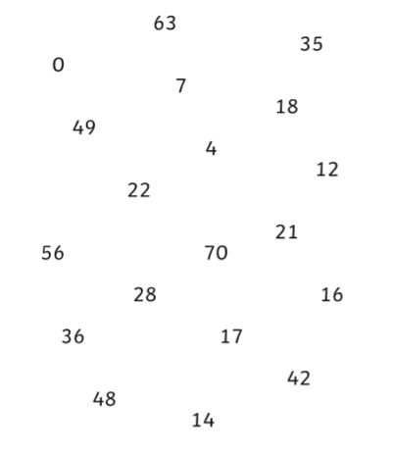
Write a newspaper article covering COVID-19. Think about important information and advice you need to give to the public to keep themselves and others safe. Could you draw a picture to accompany your report? Don’t forget to caption it!

