Year 6 – Home Learning Challenge 12
2 metres
Can you correctly answer these in 2 minutes?

How many centimetres are there in 2 m?
How many millimetres?
How many centimetres are you away from being 2m tall?
How many km are there in 2m?
How many 30cm rulers would you need to be able to measure 2m?
Would I be right in thinking ‘If used a 15cm ruler, I would need to half the amount?’
Explain your reasoning.

Spellings
Explanation | Frequently
Explanation | Government
Familiar | Guarantee
Foreign | Harass
forty | hindrance

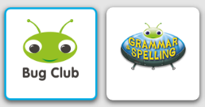
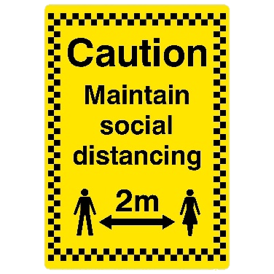

- Reading – activelearn.co.uk. Access the wide range of books on here.
- Maths – Bitesize daily is offering many Maths lessons complete with video and resources.
- Physical activity – Joe Wicks workout.
As part of English this week…
I would like you to create a short script for a play. This could be based on your favourite book, experiences in lockdown, a movie.
Consider which characters. How will you characterise them for the audience? What will you need to include to set the scene?
Complete the statement below…
‘The Number 2 is the only number which….’

