Nursery - Home Learning Challenge - Easter Week 2
Check Tapestry | Post your bears onto your page. | https://tapestryjournal.com/login/

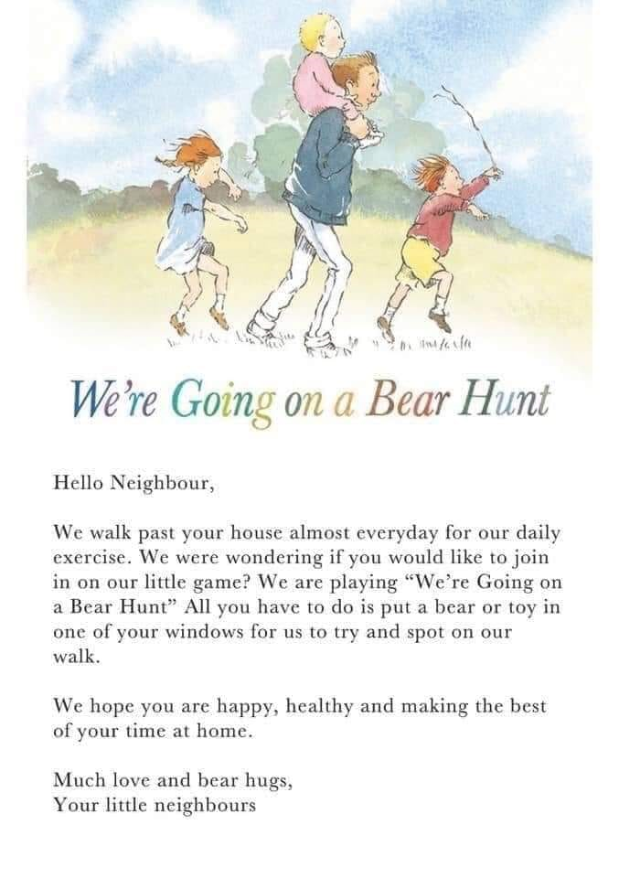How many bears can you find? Draw your favourite bear? What is its name? Can you make an outfit for your bear?

