Reception – Home learning challenge – Easter week 2

Decorate an egg!

Ask a grown up to hard boil an egg for you. Use any resources from around the house to decorate your egg. Perhaps try and make it look like your favourite cartoon character? Have a look at some ideas below! Get the whole family involved, decorate an egg each.
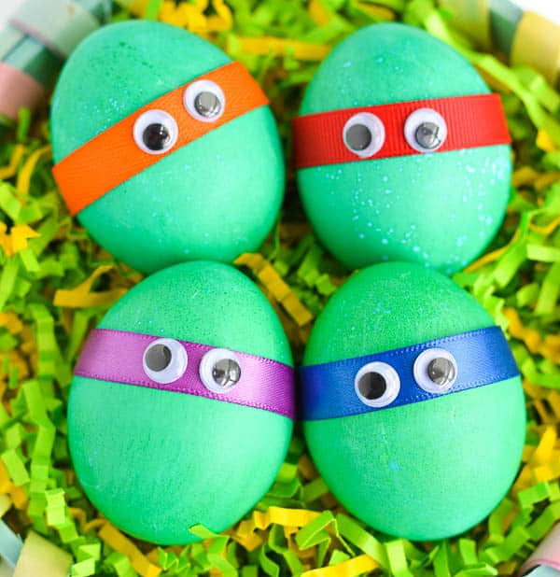

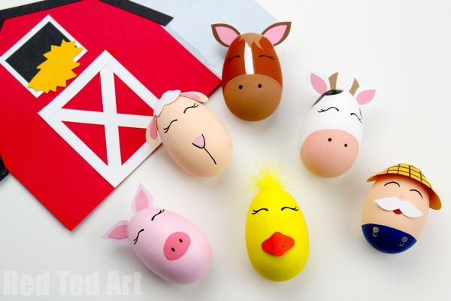

Enjoy! Upload pictures of your creations to
your Tapestry account so we can see them!

Mrs Flattley and Mrs Robertson

