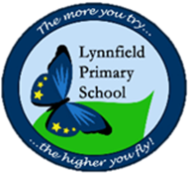
Year 2 – Home Learning Challenge – Easter Week 2
Hello, we hope you are enjoying the holidays as best you can whilst keeping you and your family members safe.

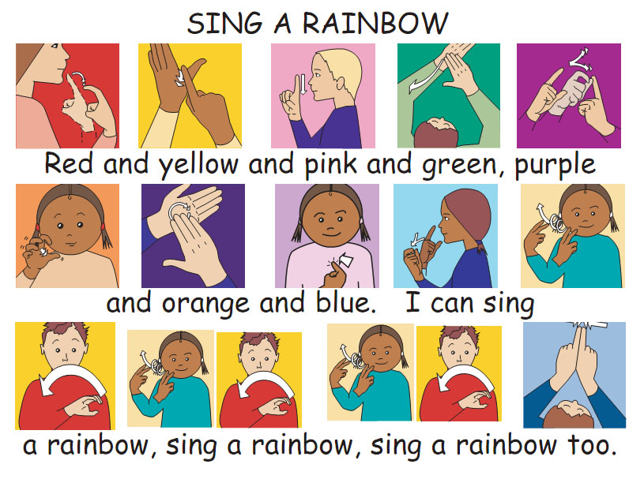
Challenge 1: Learn ‘Sing a Rainbow’ using sign language.

Challenge 2: Make an origami butterfly to hang in your window. Mrs Blundell had a go with a spare square of wrapping paper.
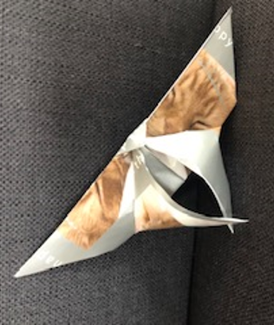
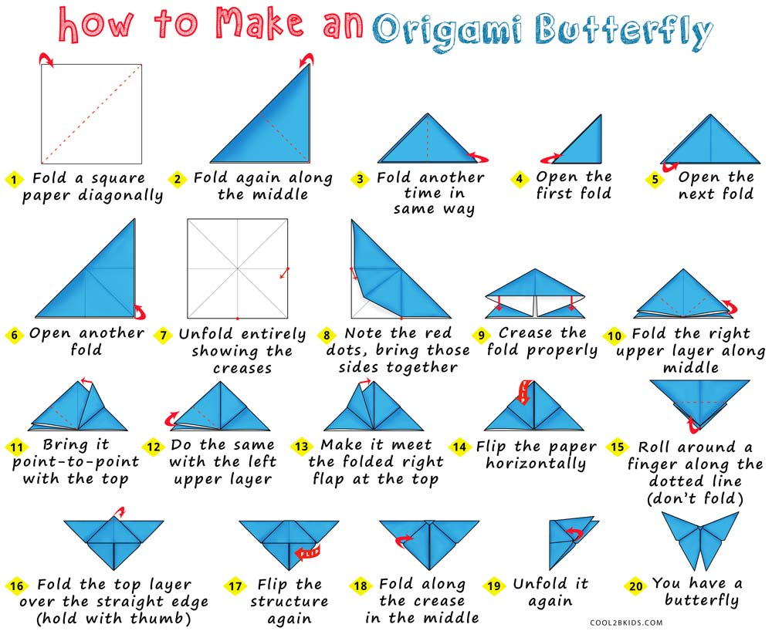

Stay Safe
Mrs Blundell, Miss Wrigglesworth and Miss Proudlock x x x

