Year 1 – Home learning challenge 4

- Reading (20 mins) – choose a book you love.
- Spelling (15 mins) – choose 2 different words a day and write them in a sentence. Try to be creative!
- Maths (15 mins) – complete a task from the fluency ladder – only move onto the next step when you are an expert! Ask people in your house to test you on a Friday (and maybe you could test them too!). Also, keep practicing your 2, 5 and 10 times tables on TTRockstars.
- Mindfulness – find a calm, quiet space and listen to some relaxing music. Lay down and imagine you are in a relaxing place.
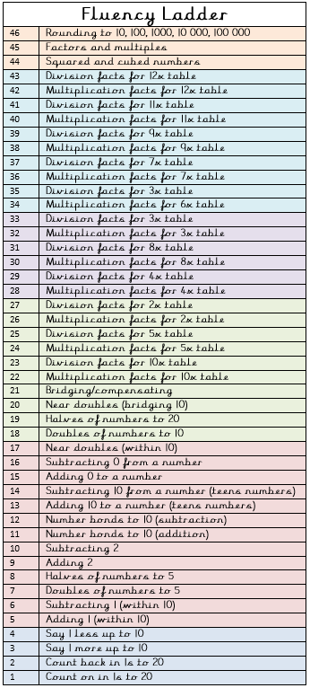
- Physical activity – how many times can you run up and down the stairs in 30 seconds? See if you can beat your score each day!
Spellings for the week
where | once
love | ask
come | friend
some | school
one | put
Weekly fun task

- Invent your own superhero. Think about what they will look like and what super powers they will have and why!

