**Year 2 – Home Learning Challenge 4**

**Daily activities**

* **Reading** (**20 mins**) – read a book and see if you can find any of your spellings.
* **Spelling (15 mins)** – practise then choose 2 of the words from the box below and write them in a sentence.
* **Maths (15 mins) –** a task from the fluency ladder – only move onto the next step when you are an expert! Ask people in your house to test you on a Friday (maybe you could test them too!). Also keep practicing your 2, 5, 10- and 3-times tables on TTRockstars.
* **Mindfulness –** Mindful Posing: Doing fun body poses can help you feel strong, brave, and happy. Go somewhere quiet, familiar and safe and try one of the following poses: ***The Superman:*** this pose is practiced by standing with the feet just wider than the hips, fists clenched, and arms reached out to the sky, stretching the body as tall as possible. ***The Wonder Woman:*** this pose is struck by standing tall with legs wider than hip-width apart and hands or fists placed on the hips. Think about how you feel after a few rounds of trying either of these poses.
* 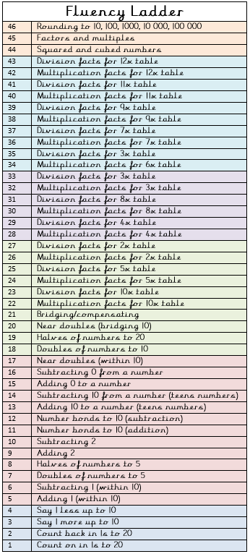**Physical activity –** Copy Captain Tom and do

laps of your garden or your bedroom

if you don’t have a garden. How many laps

can you complete in 5 minutes?

|  |  |
| --- | --- |
| Spellings for week beginning 20.04.20 | |
| tunnel | cancel |
| towel | level |
| travel | vowel |
| jewel | camel |
| label | great |
| angel | break |

Weekly fun task

