Year 4 – Home learning challenge 4

Daily activities
- Reading (20 mins) - choose a book you love.
- Spelling (15 mins) – practise then choose 2 of the words from the box below and write them in a sentence.
- Maths (15 mins) – a task from the fluency ladder – only move onto the next step when you are an expert! Ask people in your house to test you on a Friday (and maybe you could test them too!). Also keep practicing your times tables on TT Rockstars.
- Mindfulness – find a calm, quiet space and listen to some relaxing music. Lay down and imagine you are in a relaxing place.
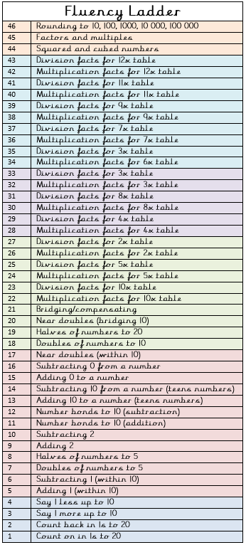
- Physical activity – how long does it take you to run up and down the stairs 20 times? How much does your time improve by the end of the week?
Spellings for week beginning 20.04.20
treasure | enclosure
measure | pleasure
leisure | closure

Weekly fun task

Create your own secret code!

- You could use numbers, letters, symbols or pictures.

- Write a message using your code and ask someone in your house to crack it.

- Will they write you a message for you to crack?

