Year 5 – Home Learning Challenge 4

Daily activities
- Reading for 20 mins per day- choose a book you love.
- Spelling (15 mins) choose 2 different words a day, find a definition of the word then write them in a sentence. Can any of your words be changed using a prefix or a suffix? If they can, write the word in another sentence using the prefix or the suffix.
- Maths (20 mins) – a task from the fluency ladder – only move onto the next step when you are an expert! Test yourself on a Friday. Also, go on to TTrockstars to try and improve your score.
- Mindfulness (10 mins) – find a calm, quiet space and listen to some relaxing music. Close your eyes, be very still and breathe in for 3 counts and out for 4 counts.
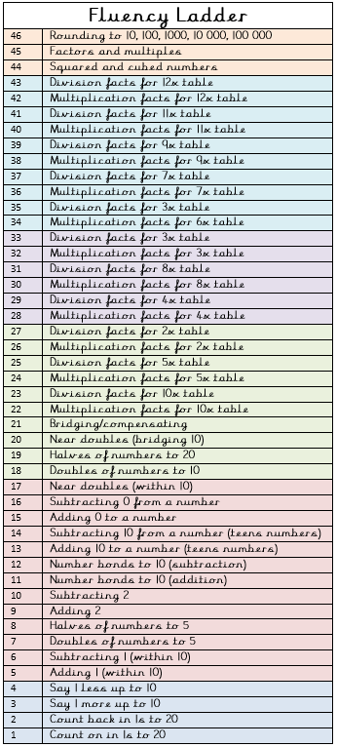
- Physical activity – complete a circuit of 15 star jumps, 15 lunges, 15 squats, 15 short sprints. Repeat 5 times with a short rest after each round. What improvements can you see by the end of the week?
Spellings for week beginning 30.03.20
Adaptable | beatable
bearable | breakable
believable | comfortable
adorable | enviable
beatable  Write a fact file about someone that inspires you.  Pick someone you look up to, it could be your favourite singer, author or footballer etc.  Use the internet to research this person. Note down their achievements and key details about their job/what they do.  Write a paragraph explaining why they inspire you.  Get a parent to take a picture of your fact file and send it over to our Facebook page for Miss Freeman and Miss Pearce to see. | miserable

“Creativity is intelligence having fun.”
Albert Einstein

