Year 6 – Home Learning Challenge 4

Daily activities
- Reading (20 mins) - choose a book you love.
- Spelling (15 mins) – choose 2 different words a day, find a definition of the word then write them in a sentence. Can any of your words be changed using a prefix or a suffix? If they can, write the word in another sentence using the prefix or the suffix.
- Maths (15 mins) – a task from the fluency ladder – only move onto the next step when you are an expert! Ask people in your house to test you on a Friday (and maybe you could test them too!). Also keep practicing your 6, 7 and 8 times tables on TTRockstars.
- Mindfulness – find a calm, quiet space and listen to some relaxing music. Lay down and imagine you are in a relaxing place.
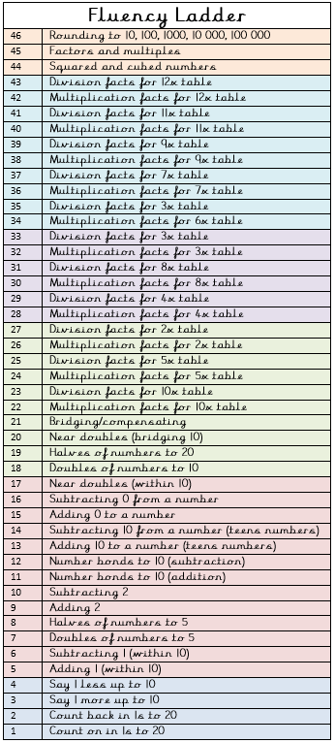
- Physical activity – complete a circuit of 15 star jumps, 15 lunges, 15 squats, 15 short sprints. Repeat 5 times with a short rest after each round. What improvements can you see by the end of the week?
Spellings for week beginning 20.04.20
achieve | foreign
bruise | hindrance
community | immediate
determined | muscle
excellent | vegetable

Weekly fun task

- Think about an important job in our world (e.g. a nurse or fire fighter).

- Research all the different tasks they might have to carry out in their job role.

- Choose the 3 tasks you think are the most important and draw each of them being carried out.

