Year 1 – Home learning challenge 5
- Reading (20 mins) – choose a book you love.
- Spelling (15 mins) – choose 2 different words a day and write them in a sentence. Try to be creative!
- Maths (15 mins) – complete a task from the fluency ladder – only move onto the next step when you are an expert! Ask people in your house to test you on a Friday (and maybe you could test them too!). Also, keep practicing your 2, 5 and 10 times tables on TTRockstars.
- Mindfulness – find a calm, quiet space and listen to some relaxing music. Lay down and imagine you are in a relaxing place.
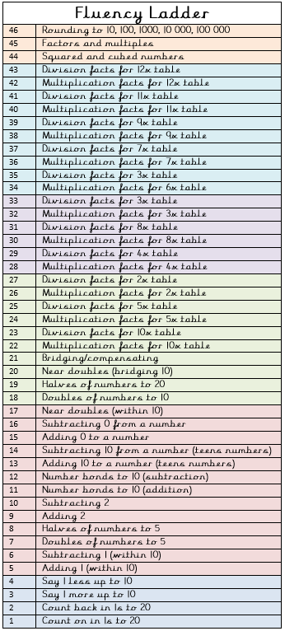
- Physical activity – why don’t you join the Body Coach for a live workout Monday – Friday at 9 a.m.? Go to YouTube and search ‘The Body Coach TV’.

Spellings for the week
huge | woke
brute | stone
cube | home
tune | froze
June | vote
Weekly fun task

- Create your own spring picture. This could be a drawing, painting or collage (or something else of your choice!). Be creative
- You could focus on what you can see from your window to help you.

