Year 2 – Home Learning Challenge 5

Daily activities
- Reading (20 mins) – read a book you enjoy.
- Spelling (15 mins) – practise then choose 2 of the words from the box below and write them in a sentence.
- Maths (15 mins) – a task from the fluency ladder – only move onto the next step when you are an expert! Ask people in your house to test you on a Friday (maybe you could test them too!). Also keep practicing your 2, 5, 10- and 3-times tables on TTRockstars.
- Mindfulness – Spidey-Senses. It’s time to turn-on your “Spidey senses,” or the super-focused senses of smell, sight, hearing, taste, and touch that Spiderman uses to keep tabs on the world around him. Find a special object in your house and look closely at it. Turn on your super spider sense of sight by noticing the different colours, patterns and shapes you can see. What do you notice that you didn’t realise was there before? Your spider-man senses are waking up! Try exploring objects uses all of your other senses.
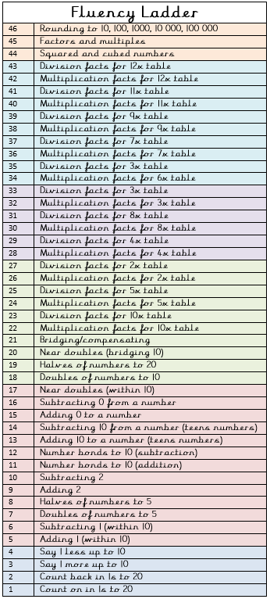
- Physical activity – Try some yoga poses!

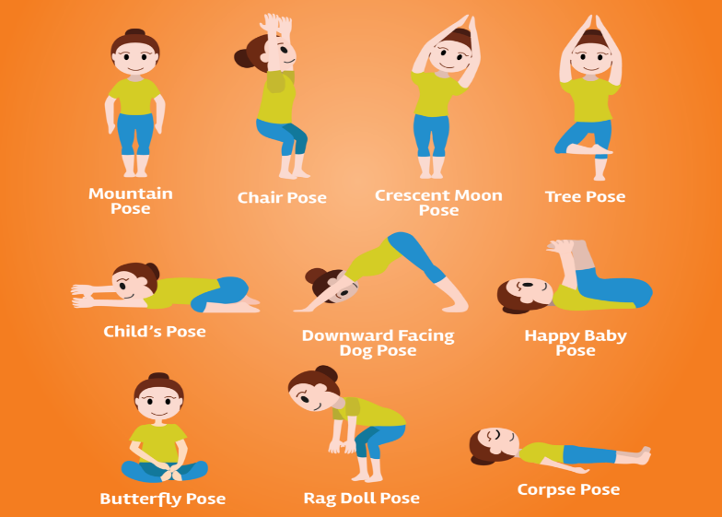

Spellings for week beginning 27.04.20
magical | animal
plural | signal
vocal | crystal
tropical | sandal
medical | should
capital | would
Weekly fun task

- Create your own TV show.
- You could use toys, puppets and even film your debut episode!

