Year 3 – Home learning challenge 5

Daily activities
- Reading for 20 mins per day- choose a book you love.
- Spelling (15 mins) practice using Look, Say, Cover, Write and Check – Test yourself on Friday.
- Maths (15 mins) – a task from the fluency ladder – only move onto the next step when you are an expert! Test yourself on Friday.
- Mindfulness (10 mins) – find a calm, quiet space and listen to some relaxing music. Close your eyes, be very still and breathe in a calming colour for 3 counts and out for 4 counts.
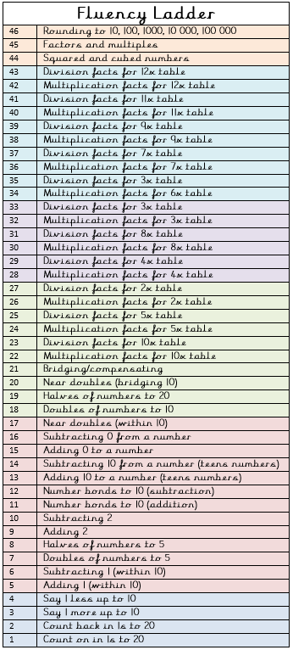
- Physical activity – Listen to a piece of upbeat music every day, turn up the volume and dance like no-one is watching! Or try Joe Wick’s workout and Oti Mabuse’s dance class at 11:30am.
Spellings
reappear | rearrange
recycle | redecorate
replace | rewrite
refresh | rebuilding
reheat  Weekly fun task – | reconnect

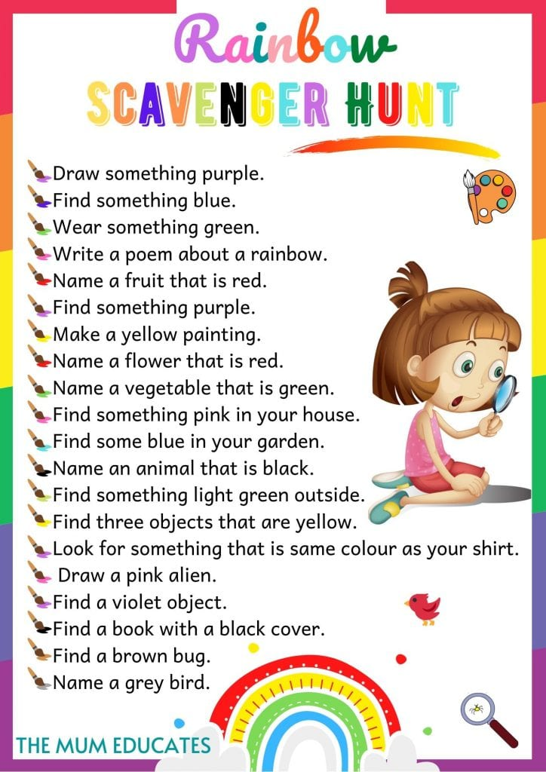
“Try to be a rainbow in someone’s cloud.”
Maya Angelou

