Year 4 – Home learning challenge 5

Daily activities
- Reading (20 mins) - choose a book you love.
- Spelling (15 mins) – practise then choose 2 of the words from the box below and write them in a sentence.
- Maths (15 mins) – a task from the fluency ladder – only move onto the next step when you are an expert! Ask people in your house to test you on a Friday (and maybe you could test them too!). Also keep practicing your times tables on TTRockstars.
- Mindfulness – find a calm, quiet space and listen to some relaxing music. Lay down and imagine you are in a relaxing place.
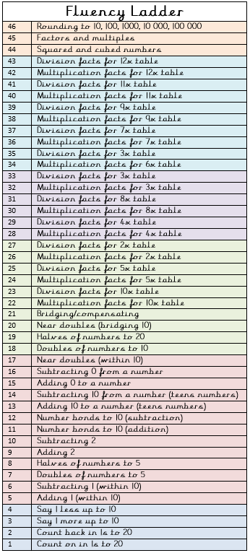
- Physical activity – create your own obstacle course in your house or in your back garden. How many times can you complete it in 5 minutes?
Spellings
automobile | autopilot
autograph | autobiography
autocue | automatic

Weekly fun task

Write a song or rap about something you enjoy.

- This could be about a subject at school, a sport you enjoy or a club you go to.

- Remember a song or rap is a poem with music.

- You could share your poem with your family or friends (over the phone).

