Year 5 – Home Learning Challenge 5

Daily activities
- Reading for 20 mins per day- choose a book you love.
- Spelling (15 mins) practice using Look, Say, Cover, Write and Check – Test yourself on a Friday.
- Maths (20 mins) – a task from the fluency ladder – only move onto the next step when you are an expert! Test yourself on a Friday.
- Mindfulness (10 mins) – find a calm, quiet space and listen to some relaxing music. Close your eyes, be very still and breathe in for 3 counts and out for 4 counts.
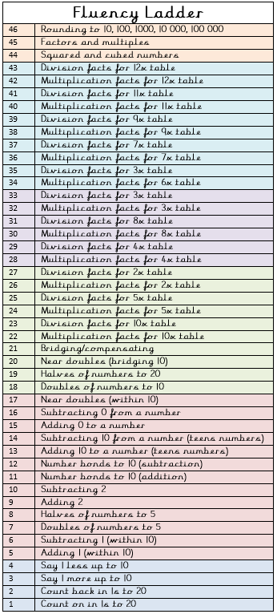
- Physical activity – Listen to a piece of upbeat music every day, turn up the volume and dance like no-one is watching! Not into dancing? Why don’t you join the Body Coach for a live workout Monday – Friday at 9am? Go to YouTube and search ‘The Body Coach TV’.
Spellings
bustle | glisten
fasten | nestle
listen | soften
hustle | rustle
castle | whistle

Weekly fun task – Write a letter to someone you can’t wait to see again!
Think about:
- Telling them what you have been doing
- Telling them what you are looking forward to doing together
- Sending kind words and positivity
“Be brave, be creative, be kind, be thankful, be happy, be you.’
Robert Brault

