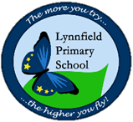
Year 6 – Home Learning Challenge 5
Hello Year 6, Hope you are all well! This week we are focussing on Maths around your home! Remember your daily activities – to be reading for 15 minutes, learning your spellings and keeping fit and healthy. Miss. Whiteside is continuing her Joe Wicks workout every morning. Are you joining in with ‘Fancy Dress Friday’?
How many handles?
Count all the door handles in your house.
What fraction of the handles have locks? Can you convert this to a percentage?
Odd Socks
Take three different pairs of socks (6 in total)
How many new pairs of socks can you make from the 6 socks you have?
How long?
Estimate the perimeter and area of a room in your house.
Now measure it. How close were you?
Contents..
How healthy is the food in your house? Sort your foods in to food groups and count the quantity of each item.
Create a bar chart to display your results.
Always read the label!
Take a box/packet of food. Add up every number on the packet.
Check your answer with a calculator.
Stop the clock star jumps
Use a stopwatch/mobile/clock to time yourself doing 15 star jumps. Have five attempts and record the time.
What was the fastest time?
What was the average time?
What was the difference between the fastest and slowest time?
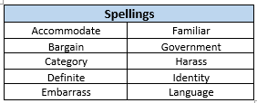
Weekly fun task
Karaoke Night
This is a fun filled night for all members of your household to enjoy.
Could you give one another a song to learn? Dress up as your favourite artist or band? Maybe perform a dance routine?

