Reception – Home learning challenge 6

These challenges will also be uploaded to Tapestry where you can easily click on the links. https://tapestryjournal.com/

Start each day… | Practise mindfulness and take part in some morning yoga. Get the whole family to join in! | https://www.youtube.com/watch?v=02E1468SdHg
Maths  Understanding the World | 3.  Ingredients:  - 500g potatoes, peeled and chopped  - 200g left over vegetables  - 20g butter  - 2tbsp vegetable oil  - Half an onion, chopped  - Handful of grated cheese  Method:  - Fill a pan with cold water. Boil potatoes until soft then drain  - Add the butter to the potatoes and mash until smooth  - Heat a frying pan with the oil  - Add the chopped onion. Fry for a few minutes  - Add the left over veg and mix. Fry for a few minutes  - Add the mashed potato and mix it with the other ingredients in the pan  - Press down the mixture in the pan with a spatula to brown and heat through  - Keep turning it over and heating it through so the edges brown  Serve and enjoy! (It’s delicious with brown sauce!)
VE Day, or Victory in Europe Day, is celebrated on the 8th of May to celebrate the day towards the end of the Second World War when the fighting against Nazi Germany in Europe came to an end.
During the war, people would use lots of home-grown vegetables to make their meals and would use left-overs to make something different the next day! Can you use left-over vegetables this week to make Bubble and Squeak with a grown up? Measure the ingredients (ask a grown up to chop them for you), mash them and follow the instructions above. Enjoy!

Phonics | 1.  https://www.youtube.com/channel/UCo7fbLgY2oA_cFCIg9GdxtQ/featured
Please go to the Ruth Miskin YouTube channel, every weekday and watch
the Speed Sounds Set 1 video from 09:30am ‘til 10:00am

Reading  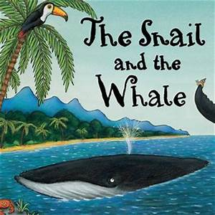 | 2.  https://www.bbc.co.uk/iplayer/episode/b0bwdw8y/zog
 | Watch the story of Zog on BBC iPlayer or read the story with an adult if you have the book at home! Then, complete the different activities each day!
Monday | What skills must Zog learn at dragon school? Write a list of these skills, titled ‘How to become a dragon...’
Tuesday | In the story, the princess dreams of being something else when she grows up. Can you write a dream for yourself for when you grow up? What do you want to be, and why?
Wednesday | Imagine you were flying on the back of Zog. What would you see whilst you were up in the air, and where would you choose to go?
Thursday | Imagine you have arrived at your chosen destination after Zog has flown you there. Can you write a postcard from that place to the people back at home?
Friday | Zog’s ‘super power’ is being able to fly. If you could have a super power, what would it be, and why?

