**Year 2 – Home Learning Challenge 6**

**Daily activities**

* **Reading** (**20 mins**) – As we prepare to celebrate VE day on 8th May we would

like you to find something to read e.g. in a paper, on a phone or an iPad and research VE day. Why is it a special day that is remembered every year?

* **Spelling (15 mins)** – practise then choose 2 of the words from the box below and write them in a sentence.
* **Maths (15 mins) –** a task from the fluency ladder – only move onto the next step when you are an expert! Ask people in your house to test you on a Friday (maybe you could test them too!). Also keep practicing your 2, 5, 10- and 3-times tables on TTRockstars.
* **Mindfulness –** Each morning when you wake up and every night when you go to bed think of something you are thankful for.
* 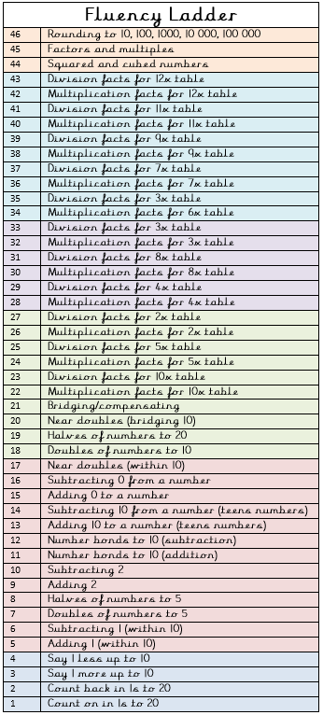**Physical activity –** Use toys to make an

obstacle course – weave around the toys or

carefully jump over the toys. Race your family

members. Who can complete the course in the

fastest time?

|  |  |  |  |
| --- | --- | --- | --- |
| Spellings for week beginning 04.05.20 | | | |
| thankful | cheerful | painful | careful |
| colourful | thoughtful | helpful | peaceful |
| wonderful | hopeful | who | whole |



Weekly fun task

Design your own VE day teacup, make it bright and eye-catching. You could include flags, important buildings or people who were involved in the Second World War. We can’t wait to see your amazing designs!

