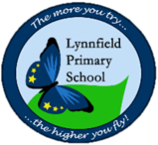
Year 3 – Home learning challenge 6
Daily activities
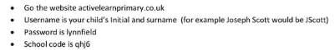
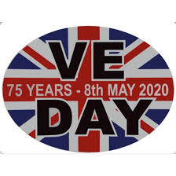
- Reading Bug club books on activelearnprimary.co.uk

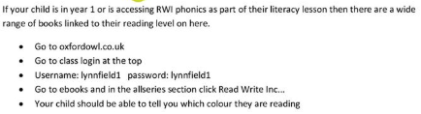.
- Physical activity – Learn the Charleston Stroll with your family- https://www.youtube.com/watch?v=1szsYNt1K_w Then bounce it up and join in with this group https://www.youtube.com/watch?v=5_lAVLZBlLY
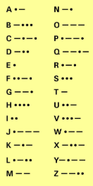
Crack this code using the Morse Code Alphabet
... - .- -.-- / ... .- ..-. . /
... - .- -.-- / .... --- -- . /
... .- ...- . / .-.. .. ...- . ...
Try writing your own

Have a VE party on Friday8th May with your family.
- Make some bunting
- Sing some songs
- Do the Charleston Stroll
- Dress up
- Make a buffet lunch
- Send your pictures and videos to our Facebook page
“Never… Never…Never…
Never give up!”
Winston Churchill
Learn this song – We’ll meet again by Vera Lynn
https://www.youtube.com/watch?v=OJKMji2688M
We'll meet again
Don't know where
Don't know when
But I know we'll meet again some sunny day
Keep smiling through
Just like you always do
'Till the blue skies drive the dark clouds far away
So will you please say hello
To the folks that I know
Tell them I won't be long
They'll be happy to know
That as you saw me go
I was singing this song
We'll meet again
Don't know where
Don't know when
But I know we'll meet again some sunny day

