Year 4 – Home learning challenge 6
Daily activities
Reading – access BugClub. On there you have a choice of books, remember to click on the bugs on certain pages to answer questions. David Walliams is also reading some of his books for free https://www.worldofdavidwalliams.com/watch-and-listen/
Maths- Keep practicing your times tables on TTRockstars. You could also have some fun on Guardians, Defenders of Mathematica https://www.bbc.co.uk/bitesize/topics/zd2f7nb/articles/zn2y7nb
Weekly fun task

This week on Friday 8th May it will be VE day.

- Can you research what anniversary this day marks? Listen to Winston Churchills famous speech.

- Have a picnic in the garden or front street. Make your own bunting (https://www.twinkl.co.uk/resource/t-t-2548139-union-jack-template-display-bunting), create sandwiches and cakes and listen to some 1940’s music https://www.youtube.com/watch?v=FsynSgeo_Uo you could even learn swing dancing! https://www.youtube.com/watch?v=IYu4p0S4bZc

- Create some fun paper aeroplanes. If you have a printer you can print the following or you can create your own designs! (https://www.twinkl.co.uk/resource/t2-t-803-simple-ww2-spitfire-glider-activity-paper-craft).

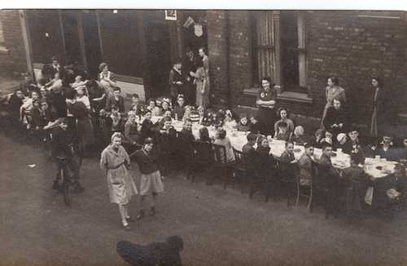
Street Party in Sherriff Street
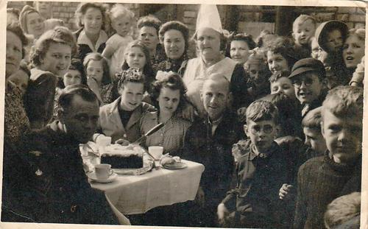
Celebrating V.E. Day in Everett Street in 1945.
Can you find any other pictures or pieces of information about VE day celebrations that took part in Hartlepool? Or perhaps what your street and surrounding area looked like in the 1940s? If you do please share via Lynnfield’s Facebook page!

