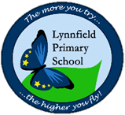
Year 5 – Home Learning Challenge 6
Hi Y5, just a quick message to let you know we are missing you very much and we hope you and your family are staying safe at home. We are looking forward to the day we can be all back school again safely.
Miss Freeman and Miss Pearce
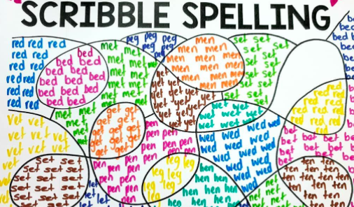
Daily activities
- Reading for 20 mins per day- choose a book you love.
- Spelling (15 mins) Use this weeks spelling list to create a spelling scribble. Use one colour to create a swirly scribble on your paper. Fill the gaps of your scribble with a spelling of your choice in different colours.
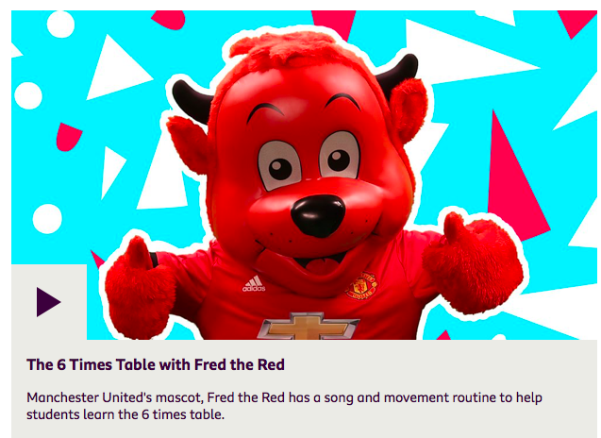
- Maths (20 mins) – Pick the multiplication you are struggling on and use BBC supermovers to help you learn them.
- Mindfulness (10 mins) – Have a go at doing some yoga. Search ‘Yoga Ed’ into YouTube and try out one of their yoga sessions.
- Physical activity – Listen to a piece of upbeat music every day, turn up the volume and dance like
- no-one is watching! Not into dancing? Why don’t you join the Body Coach for a live workout
- Monday – Friday at 9am? Go to YouTube and search ‘The Body Coach TV’.

Weekly fun task

Draw an alien that Liam from our class text ‘Cosmic’ might meet in space.
Try to make it as weird as possible!
Describe your alien to a family member without showing them and see if they can re-create your drawing. 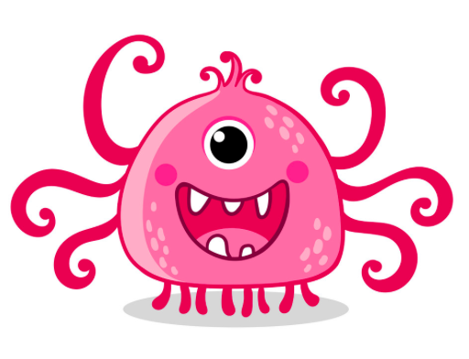
Spellings
Conceit | Deceive
Protein | Ceiling
Either | Neither
Caffeine | Receive
Seize | Perceive

75th Anniversary of VE Day
Watch this BBC clip to find out more about this event https://www.bbc.co.uk/teach/class-clips-video/history-ks2-ve-day/z7xtmfr.
Complete these activities to celebrate the event.
- Create a poster that celebrates VE day
- Think about how you would feel living at that time and write a short diary entry explaining how you felt when you heard the news.
- Plan what you would serve for a street party to mark the end the war in Europe.

