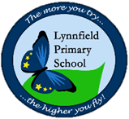
Year 6 – Home Learning Challenge 6
Hello Year 6, hope you enjoyed your Maths activities last week, this week, I want you to use your imagination. Continue your reading, spellings and focus on your physical and mental health. This will keep your spirits high!
75th anniversary of VE Day
Think back to our WW2 topic. Watch the clip:
http://www.bbc.co.uk/teach/class-clips-video/history -ks2-ve-day/z7xtmfr
Write a short diary extract of what we have to be grateful for right now.
Creative characters..
Not all superheroes come in Marvel films.
We are surrounded by them.
Create your own hero, describe their characteristics, what makes the special. Could they appear in your ‘other world’? Remember to be ambitious with your vocabulary!
Words for Words.
Choose the book you have been reading this week. Turn to a random page, choose a sentence.
Identify which word class each word belongs to.

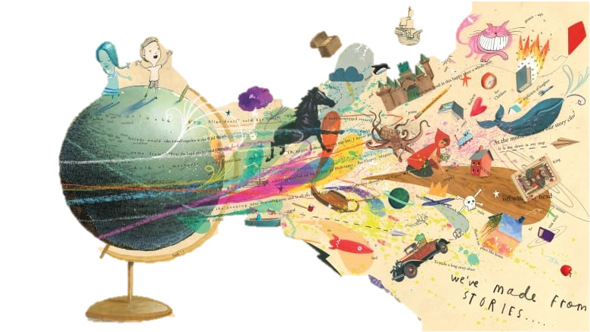
Another world?
During lockdown, if you could travel to anywhere in the world? Where would it be?
What can you hear?
What can you see?
How does it make you feel?
Write a paragraph to describe the setting. Could you start with the following?
Waking up in a pool of sweat, the sun glared in my eyes…
Shaking in anticipation, I turned the eerie key in the lock. What lie beneath should have never have been unveiled..
Weekly fun task
Plan what you would serve for a street party to end the war in Europe and host a tea party.
How will you celebrate the end of lockdown?
Spellings
This week – challenge yourself – what words do you commonly get wrong? Take the time to try and practise!
How many of the Y5 Y6 spellings can you include within your diary entry?

