Reception – Home learning challenge 7

These challenges will also be uploaded to Tapestry where you can easily click on the links. https://tapestryjournal.com/

Start each day… | Practise mindfulness and take part in some morning yoga. Get the whole family to join in! | https://www.youtube.com/watch?v=LhYtcadR9nw
Understanding the World | 3.
 | What can you find out about the life cycle of a butterfly? Use the internet and books to find out facts. Can someone in your house help you? Look at the pictures above. Can you label them and put them into the correct order?

Phonics | 1.  https://www.youtube.com/channel/UCo7fbLgY2oA_cFCIg9GdxtQ/featured
 | Please go to the Ruth Miskin YouTube channel, every weekday and watch the Speed Sounds Set 1 video from 09:30am ‘til 10:00am

Reading  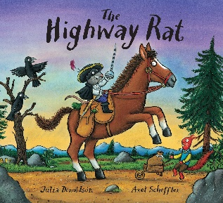 | 2.  https://www.bbc.co.uk/iplayer/episode/b09kkt1k/the-highway-rat |  | Maths  One more  & one less | 4.  https://www.topmarks.co.uk/learning-to-count/chopper-squad
 | Watch the story of The Highway Rat on BBC iPlayer or read the story with an adult if you have the book at home! Then, complete the different activities each day! |  |  | Play the game above and practise finding one more and one less than a given number. Then, complete the activities below across the week.
Monday | In the story, the Highway Rat steals from others around him. Can you make a wanted poster for the Highway Rat, listing his name, what he looks like and his crimes? |  | Monday | Ask your grown-up to tell you a number. Place this number of raisins or cereal pieces on your plate. If your grown-up says ‘one more’, can you add one more and say the number you have? If your grown-up says ‘one less’, can you eat one then count the number you have left?
Tuesday | At the end of the story, the cunning duck becomes the hero of the story by saving the day. If you were the hero in the story, what would you do to stop the Highway Rat from stealing? How would you help? |  | Tuesday | There are 6 frogs on a log. One jumps into the pond. How many frogs are left on the log? Can you draw a picture to show the number of frogs?
Wednesday | Can you write a book/story review of the Highway Rat? What did you like/dislike about the story, and why? Is there anything you would have changed about it? |  | Wednesday | Build a tower with 7 toys/items. Can you build two more towers, one that uses one less than 7 items and one that uses one more than 7? Can you put these in an order? What do you notice?
Thursday | The Highway Rat finally gets caught out for his unkind acts towards others. Can you make a newspaper report about the moment he is caught out and what happens to him? |  | Thursday | Ask a grown-up to draw a spotty snake. How many spots does it have?  Can you count them? Can you draw a snake that has one less spot?
Friday | Can you write an apology from the Highway Rat to the other animals that he stole from to say sorry for what he had done and ask for their forgiveness? |  | Friday | Park 5 toys in pretend car park. If one drives away, will there be more or fewer toys? Drive one away and check by counting. Park a different number of toys in the car park and do this again.

