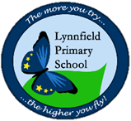
Year 1 – Home learning challenge 7
- Reading (20 mins) – choose a book you love.
- Spelling (15 mins) – choose 2 different words a day and write them in a sentence. Try to be creative!
- Maths (15 mins) – complete a task from the fluency ladder – only move onto the next step when you are an expert! Ask people in your house to test you on a Friday (and maybe you could test them too!). Also, keep practicing your 2, 5 and 10 times tables.
- Mindfulness – find a calm, quiet space and listen to some relaxing music. Lay down and imagine you are in a relaxing place.
- Physical activity – why don’t you try some yoga poses?! Use the examples below to help you or have a look on YouTube! (‘Frozen’ Yoga is a good one )
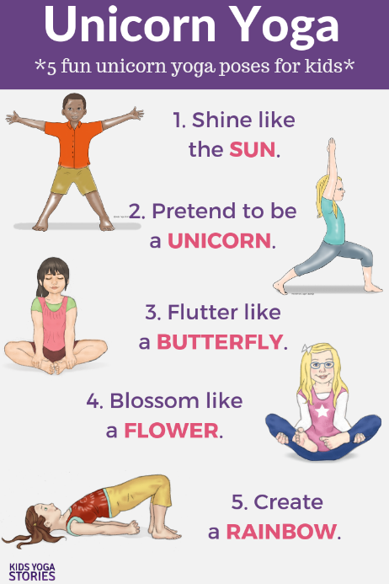
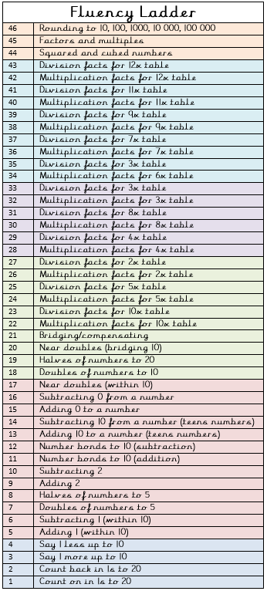

Spellings for the week
very | family
happy | sticky
funny | hairy
silly | sunny
party | lucky

Weekly fun task

Create a rainbow sun catcher!

- Get a plain piece of paper (A4).
- Draw the outline of a rainbow in the middle of the paper (as shown)
- Cut out the rainbow you have drawn (you should be left with an A4 piece of paper with a rainbow-shaped hole in the middle
- Cut up different coloured tissue paper into small squares
- Stick the tissue paper around the edge of the rainbow-shaped hole and then start to fill it in until the hole is completely covered (this can be in any pattern you like!)
- Cut around the rainbow you have made. You should end up with something like this! 