**Year 2 – Home Learning Challenge 7**

**Daily activities**

* **Reading** (**20 mins**) – read a book you enjoy.
* **Spelling (15 mins)** – practise then choose 2 of the words from the box below and write them in a sentence.
* **Maths (15 mins) –** a task from the fluency ladder – only move onto the next step when you are an expert! Ask people in your house to test you on a Friday (maybe you could test them too!). Also keep practicing your 2, 5, 10- and 3-times tables on TTRockstars.
* **Mindfulness –** Just One Breath. Find a relaxing place, sit comfortably, and set a timer for 1 minute. Breathe deeply in and out while paying attention to any sensations you notice or sounds you hear. Take another slow deep breath, imagine the air moving down into the lung and back up. Take one more deep breath and hold for a moment, then release it. Repeat until your timer runs out.
* 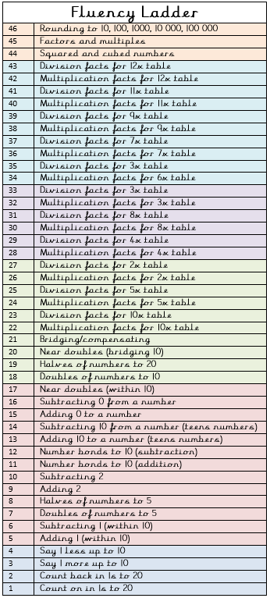**Physical activity –** Make and then try to complete

an obstacle maze.

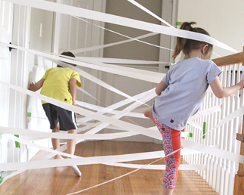

|  |  |
| --- | --- |
| Spellings for the week 11.05.20 | |
| fearless | useless |
| hopeless | restless |
| painless | harmless |
| pointless | endless |
| sleepless | worse |
| helpless | workers |

Weekly fun task

