Year 3 – Home learning challenge 7
Daily activities
- Reading Bug Club on activelearnprimary.co.uk and answer the quizzes
- Spelling (15 mins) practice using Look, Say, Cover, Write and Check – Test yourself on Friday.
- Maths (15 mins) – a task from the fluency ladder – only move onto the next step when you are an expert! Test yourself on Friday.
- Mindfulness- Try https://www.youtube.com/user/CosmicKidsYoga
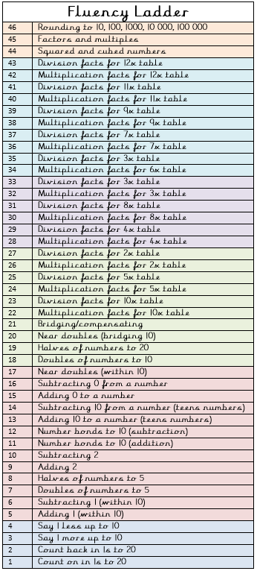
- Physical activity – Listen to a piece of upbeat music every day, turn up the volume and dance like no-one is watching! Or try Joe Wick’s workout and Oti Mabuse’s dance class at 11:30am.
Spellings
reappear | rearrange
recycle | redecorate
replace | rewrite
refresh | rebuilding
reheat  Weekly fun task –  Design and make an obstacle race course using suitable materials from around the house.  - Plan it  - Draw it  - Make it  - Race it  - Who can complete it in the fastest time?  Can you make it more challenging? | reconnect

“You won’t know what you
can do until you try!”

