Year 4 – Home learning challenge 5
Daily activities
- Reading (20 mins) - choose a book you love.
- Spelling (15 mins) – practise then choose 2 of the words from the box below and write them in a sentence.
- Maths (15 mins) – a task from the fluency ladder – only move onto the next step when you are an expert! Ask people in your house to test you on a Friday (and maybe you could test them too!). Also keep practicing your times tables on TTRockstars.
- Mindfulness – find a calm, quiet space and listen to some relaxing music. Lay down and imagine you are in a relaxing place.
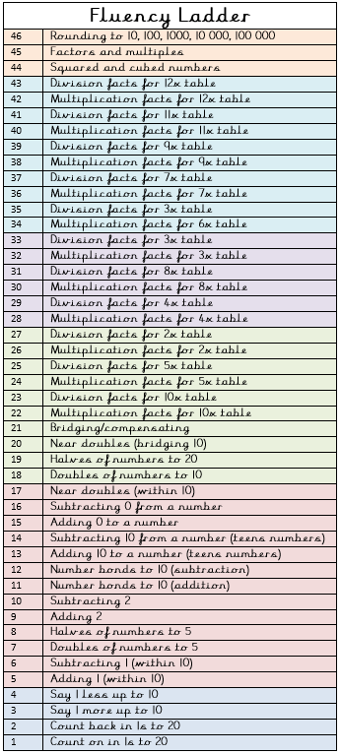
- Physical activity – try and hop on one foot for 30 seconds – how many can you do? Try it on the other foot? Can these numbers increase by the end of the week?
Spellings for week beginning
20.4.20
intergalactic | international
internet | interrelate
interact | intercity
interlock | intermediate
Weekly fun task

Draw a view

- Look out of a window in your house.

- Draw what you can see.

- Now draw what you would like to see when you look out of your window.

