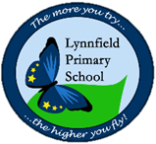
Year 6 – Home Learning Challenge 7
Hello Year 6, Sending lots of virtual smiles your way. .
- Reading - How many of you are accessing your active learn? There are many wonderful books to choose from as well as opportunities to revise grammar skills. We are checking regularly to see if more work is required
- Maths (20 mins) I have attached fluency questions. Check you answers – if you can – by using the inverse operation.
- Mindfulness (10 mins) – Switch off from media for 5 minutes per day, look around you, what can you see? What can you hear?
Spellings
Achieve | Appreciate
Aggressive | Attached
Amateur | Available
Ancient | awkward
Apparent | average
Maths - Arithmetic
3456 + 4342 | 100 x 3.45
345 / 5 | 4.5 x 5
1000 – 346 | ? = 6364 - 364
7 x 8 x 9 | ½ x ¼
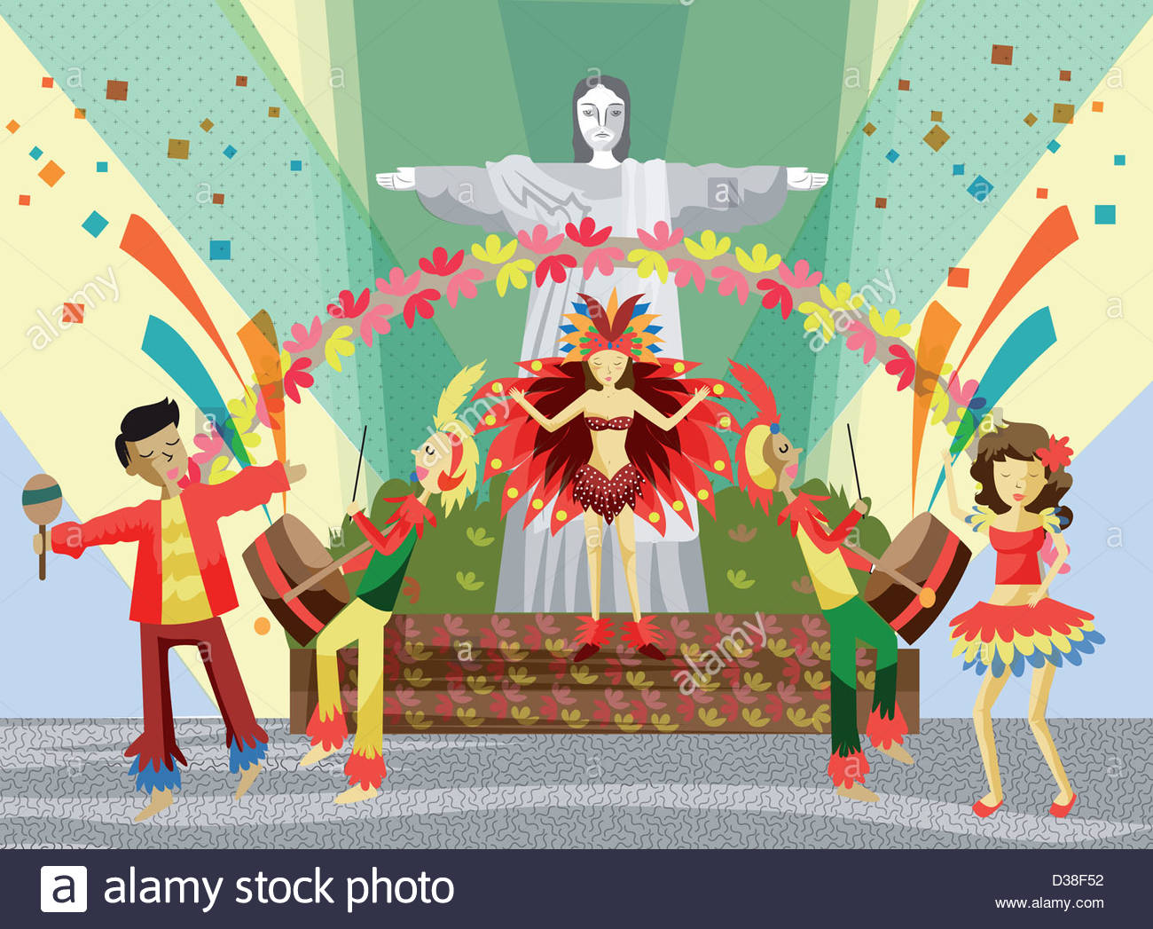
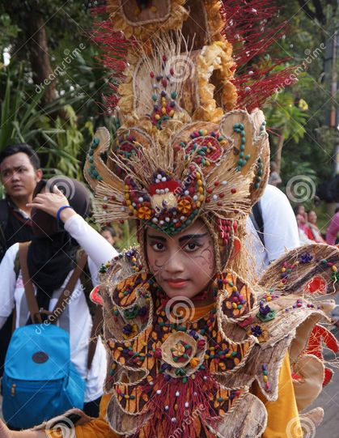
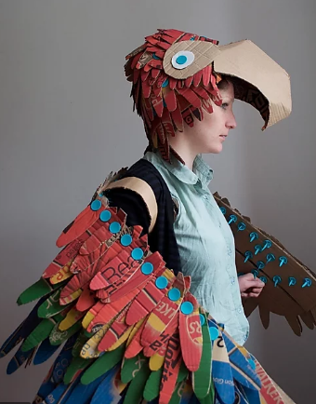
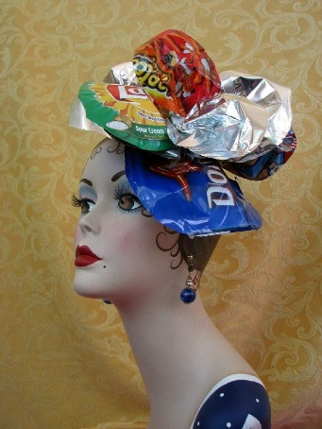
As we did not get to complete out Design and technology, why not have a go this week?
To design a hat, fascinator or headdress, suitable for
Rio Carnival.
However…
You must create this using recycled materials. Below, are some examples.

