Nursery – Home Learning Challenge 8
Start each day | Practise mindfulness and take part in some morning yoga. Get the whole family to join in | https://www.cosmickids.com/
Check Tapestry | Log on to your Tapestry account and check the memo page.  Don’t forget to add your own photos. | https://tapestryjournal.com/login/

Incy Wincy Spider

Talk about and make spiders
Talk about spiders and how they have 8 legs. Your spider’s legs could be made from strips of cardboard, paper straws, wool or pipe cleaners. Can you count out loud together up to 8?

Sing the rhyme
This is a great rhyme to sing together.
‘Incy Wincy Spider climbed up the water spout,
Down came the rain and washed the spider out.
Out came the sunshine and dried up all the rain,
So, Incy Wincy Spider climbed up the spout again’
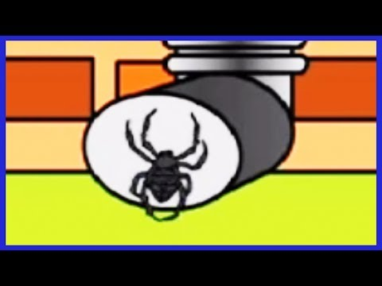

Draw or make spider webs
You could cut out a piece of card, draw on lines and then create some holes. You can then weave a web using some wool or string. You could also make your own paper spider to sit on the web.

