**Year 1 – Home learning challenge 8**



* **Reading** **(20 mins)** – choose a new book to read – one you have not read before or for a long time.
* **Spelling (15 mins)** – choose 2 different words a day and write them in a sentence. Try to be creative!
* **Maths (15 mins) –** complete a task from the fluency ladder – only move onto the next step when you are an expert! Ask people in your house to test you on a Friday (and maybe you could test them too!). Also, keep practicing your 2, 5 and 10 times tables on TTRockstars.
* **Mindfulness –** find a calm, quiet space and listen to some relaxing music. Lay down and imagine you are in a relaxing place.
* 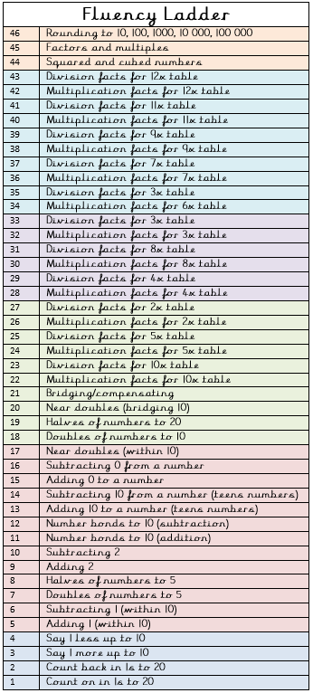**Physical activity –** why don’t you join the Body Coach for a live workout Monday – Friday at 9 a.m.? Go to YouTube and search ‘The Body Coach TV’.

|  |  |
| --- | --- |
| Spellings for the week | |
| better | turn |
| sister | burn |
| letter | hurt |
| summer | church |
| winter | Thursday |

Weekly fun task

