Year 2 – Home Learning Challenge 8

Daily activities
- Reading (20 mins) – read a book you enjoy.
- Spelling (15 mins) – practise then choose 2 of the words from the box below and write them in a sentence.
- Maths (15 mins) – a task from the fluency ladder – only move onto the next step when you are an expert! Ask people in your house to test you on a Friday (maybe you could test them too!). Also keep practicing your 2, 5, 10- and 3-times tables on TTRockstars.
- Mindfulness – Shark fin: Place the side of your hand on your forehead, with your palm facing out to the side. Close your eyes. Slide your hand down your face, in front of your nose. Say “shhh” as you slide your hand down your face. If you are sitting down, you do the 5 Ss while you move your hand: Sit up straight, sit still, sit silently, soft breathing, shut eyes. If you are standing do the same but you are standing straight, still, silently, using soft breathing, and shut eyes while you move your hand down your face.
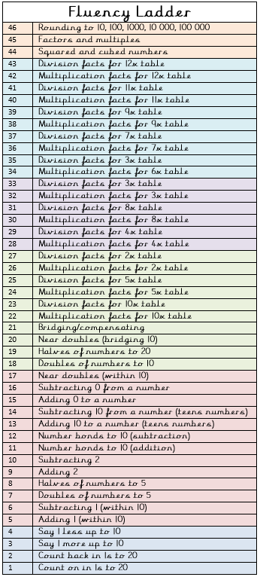
- Physical activity –Try some calm down yoga poses.
Spellings for the week
18.05.20
treatment
enjoyment
amazement
attachment
movement
judgement
punishment
replacement
payment
agreement
prove
move
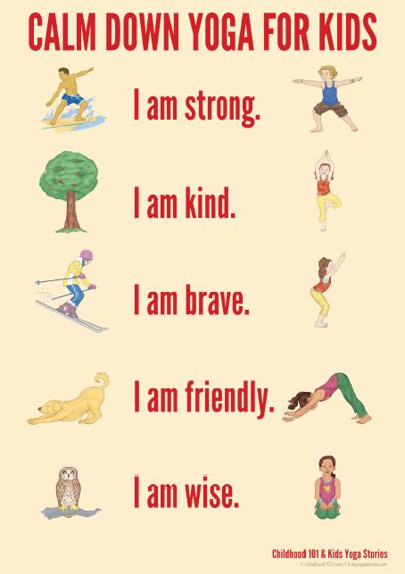

Weekly fun task – Wacky Racer Car

Design your very own Wacky Racer car! Think about what you will add to your design to make your Wacky Racer different and special to you.

