Year 3 – Home learning challenge 8
Daily activities
- Reading Bug Club on activelearnprimary.co.uk and answer the quizzes or Oxford Owl RWI https://www.oxfordowl.co.uk/
- Spelling (15 mins) practice using Look, Say, Cover, Write and Check – Test yourself on Friday.
- Maths (15 mins) – a task from the fluency ladder – only move onto the next step when you are an expert! Test yourself on Friday.
- Mindfulness- Try https://www.youtube.com/user/CosmicKidsYoga
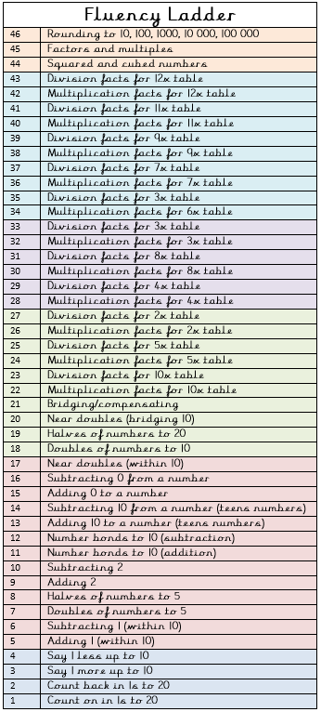
- Physical activity – Listen to a piece of upbeat music every day, turn up the volume and dance like no-one is watching! Or try Joe Wick’s workout and Oti Mabuse’s dance class at 11:30am.
“May is National Smile Month
Learn this poem by Spike Milligan and recite it.

Spellings
antibiotic | anticlockwise
anticlimax | antifreeze
antiseptic | antisocial

