Year 4 – Home learning challenge 8

Daily activities
- Reading (20 mins) – look at books available on Bug Club and remember to answer the questions throughout.
- Spelling (15 mins) – practise then choose 2 of the words from the box below and write them in a sentence.
- Maths (15 mins) – a task from the fluency ladder – only move onto the next step when you are an expert! Ask people in your house to test you on a Friday (and maybe you could test them too!). Also keep practicing your times tables on TTRockstars. www.timestables.co.uk have some fun times tables games you could also try out.
- Mindfulness – do a puzzle together. You don’t have to complete it in one day, you can always come back to it.
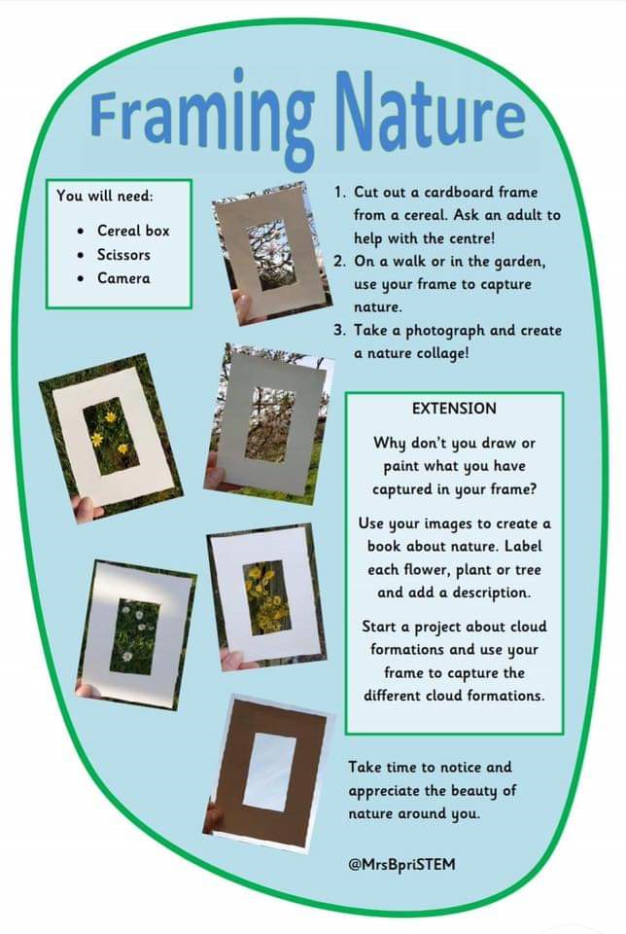
- Physical activity – balance something soft on your head (like a cushion or teddy). Can you walk, run, hop and jump around your back garden / yard without the object falling off? Can you speed up?
Spellings

grey | eighty
eight | weigh
vein | rein
veil | sleigh
obey | weight
prey | freight
neigh | eighteen

Weekly fun task
Be kind

- Do something kind for someone you know.

- Draw them a picture or make them something and let them know how special they are to you. Or have a go at the nature frame shown to the right.

- You could draw around yourselves and create a hug to send to someone you miss.

